Delegating Zoom Scheduling (so that someone can create a zoom room meeting with you as host)
- Open the Zoom client on your computer (PC: click start and type zoom MacOS: Finder -> Applications)
- In Zoom click the gear icon below your portrait
- 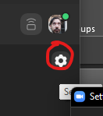
- Click on Profile then ‘View Advanced Features’
- 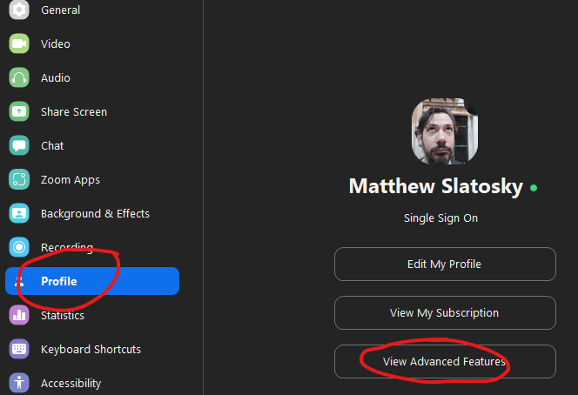
- Zoom will open a settings page in a browser. Scroll to the very bottom of that page.
- Under Schedule Privilege click Add or Edit to a delegate.
- 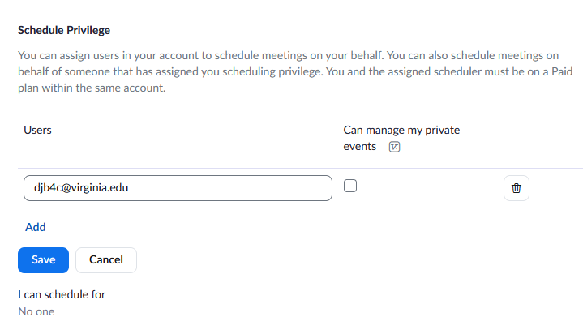
- If you are hosting a meeting in 235 or 120 you can now have the delegate create a meeting with you as the host.

