Workday Requisitions Instructions and assigning a shopping cart
Step 1: Log on to Workday.
Step 2: Click the “Menu” button on the top left of the screen.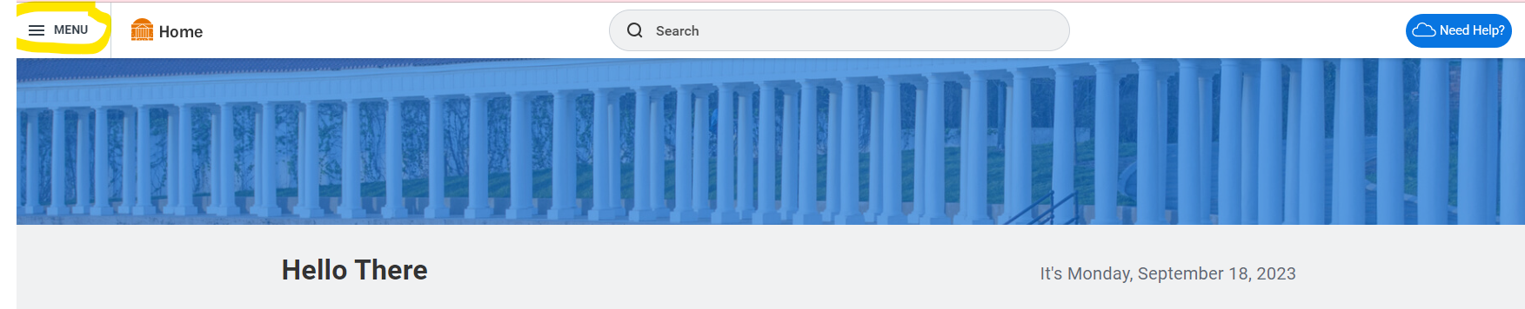
Step 3: Click the “Requisitions” App.
*Note: if “Requisitions” does not show up for you, you will have to add the App to your menu by clicking the “+Add Apps” button.
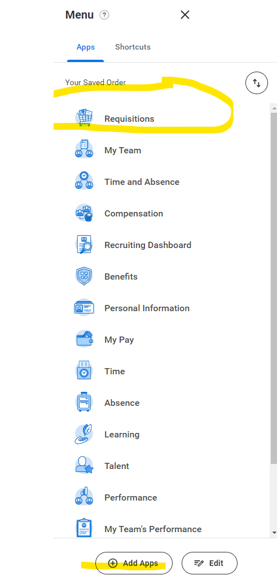

Step 4: Under “Ordering Methods” section click the “Connect to Supplier Website” button.
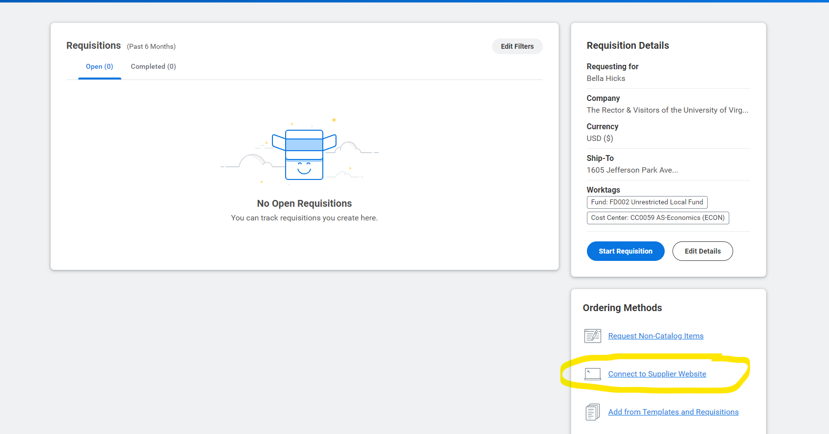

Step 5: Click the white “Connect” button in the top right of the screen.
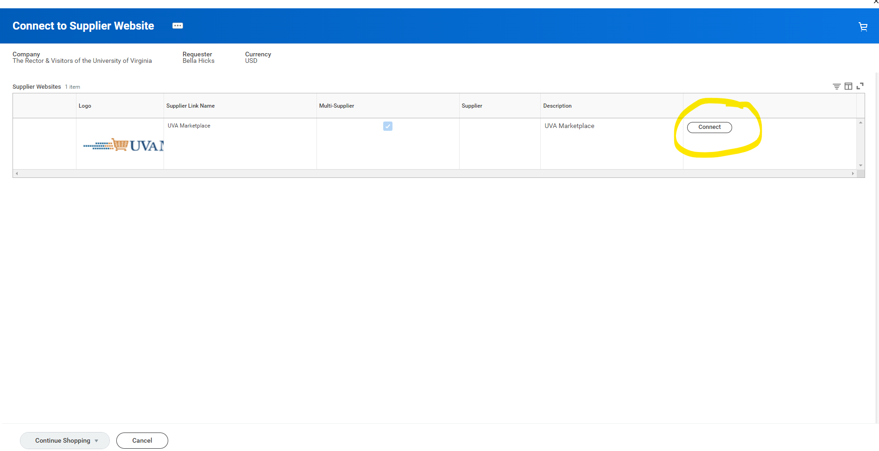

Step 6: Click “America To Go” as the supplier.
*Note this instruction manual will use Mellow Mushroom via America To Go as the vendor example. You will need to choose whichever supplier you would like to order from. You can skip to Step 8 if ordering from America To Go does not apply to you.
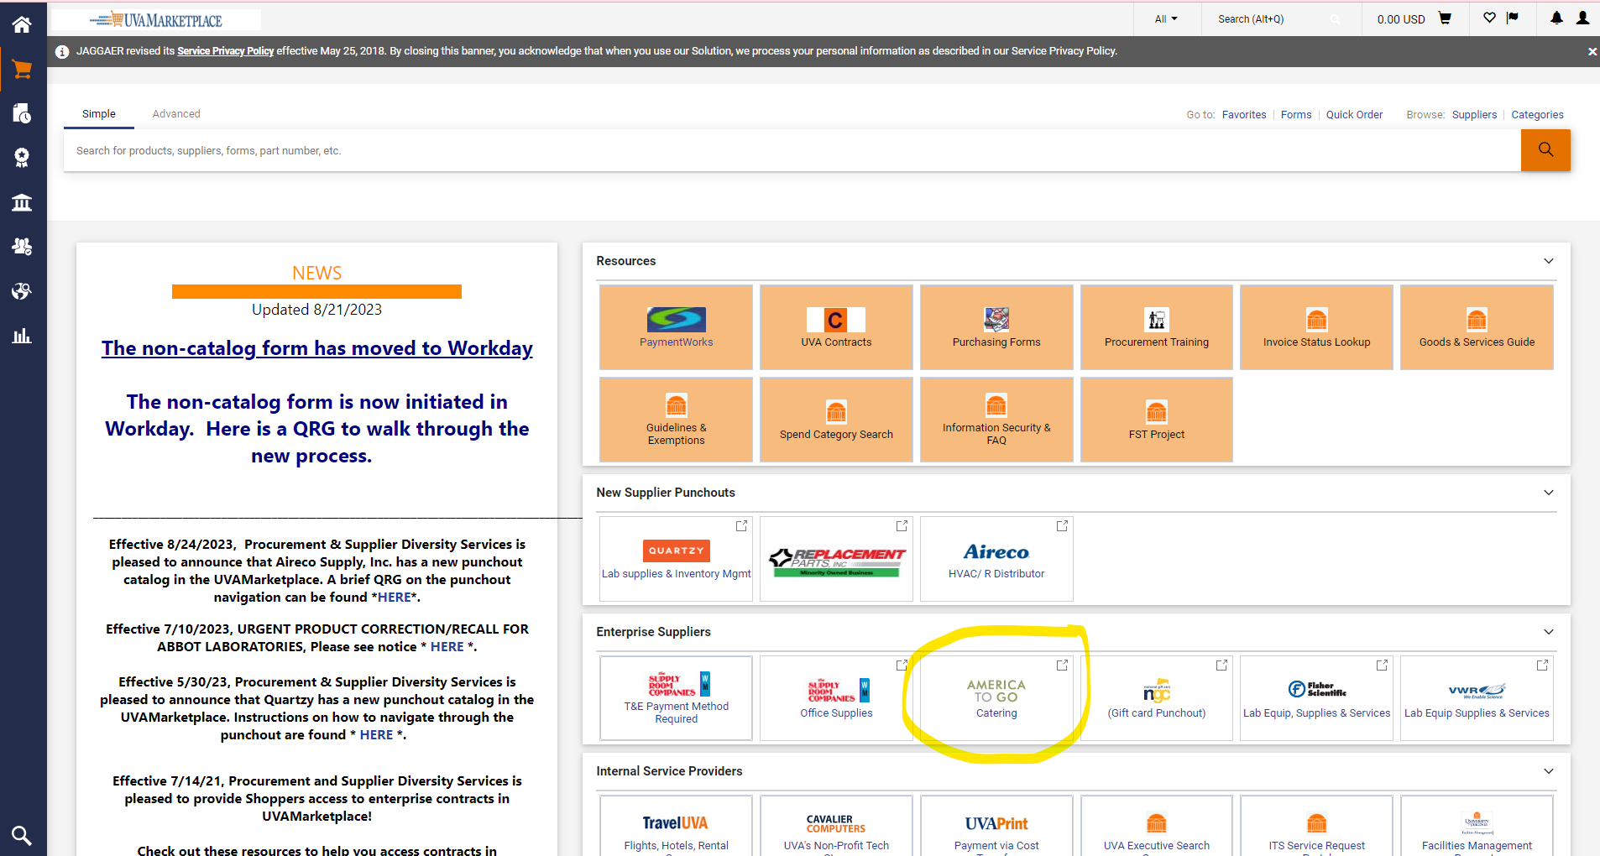

Step 7: Follow the prompts in the green column on the left side of the screen to place your order.
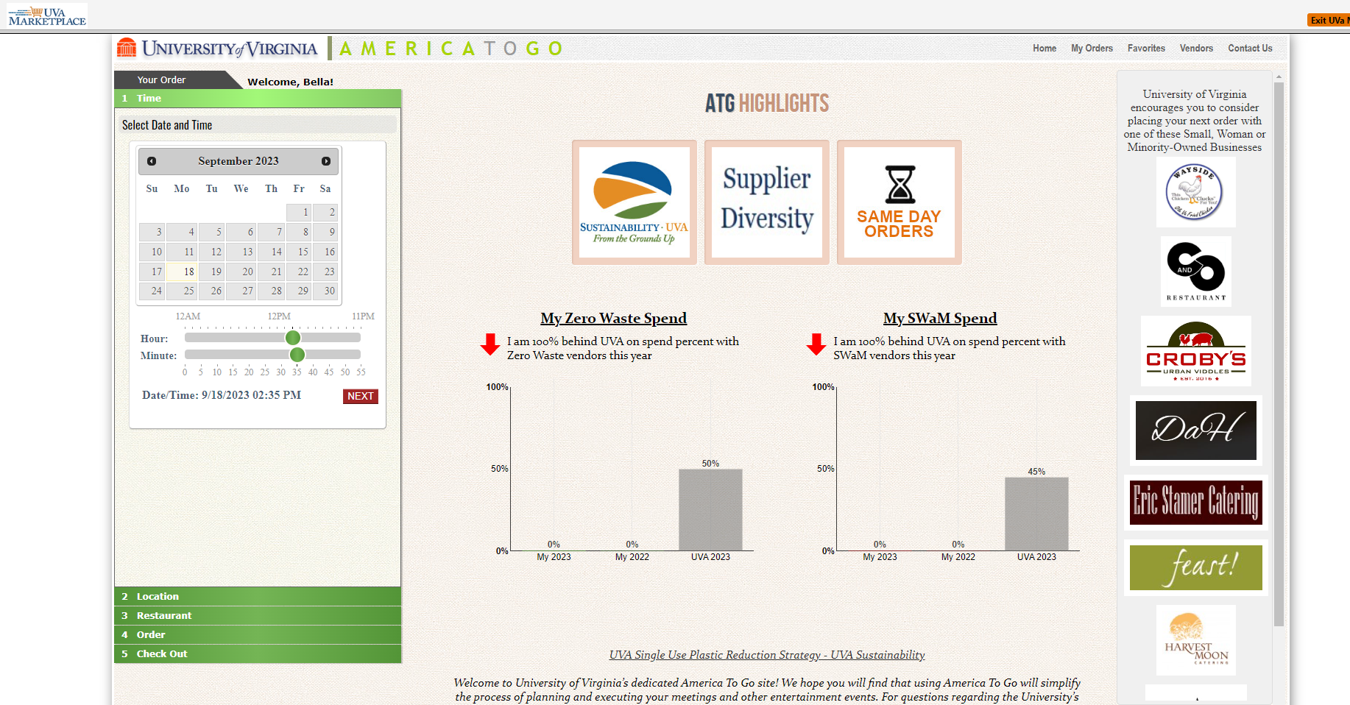
Step 7A: Enter the date/time using the calendar/green slider buttons.
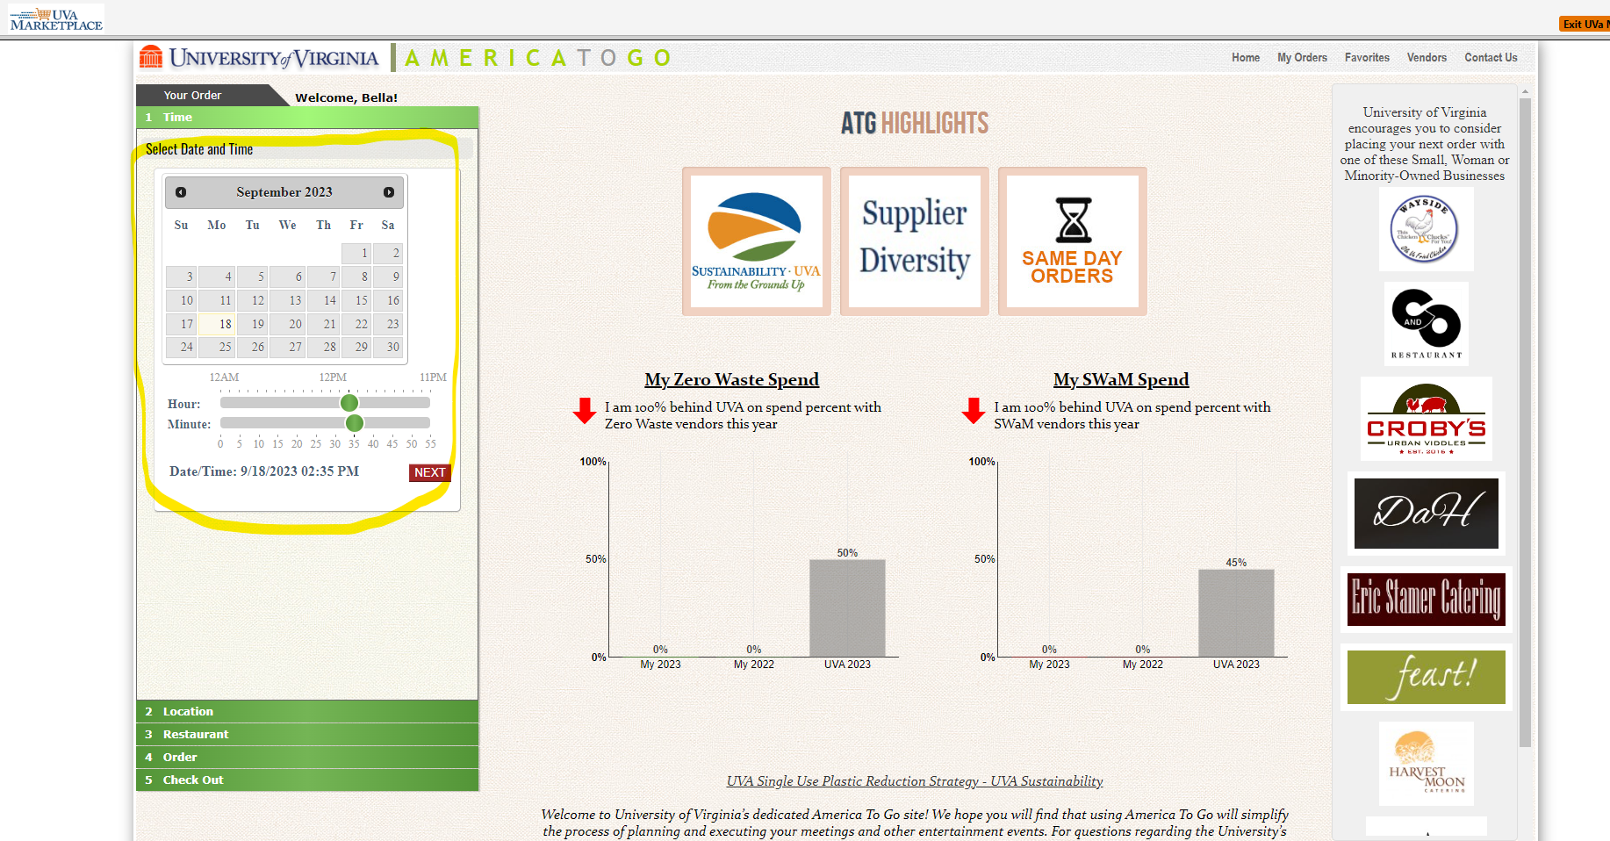

Step 7B: Click your location “Charlottesville”.
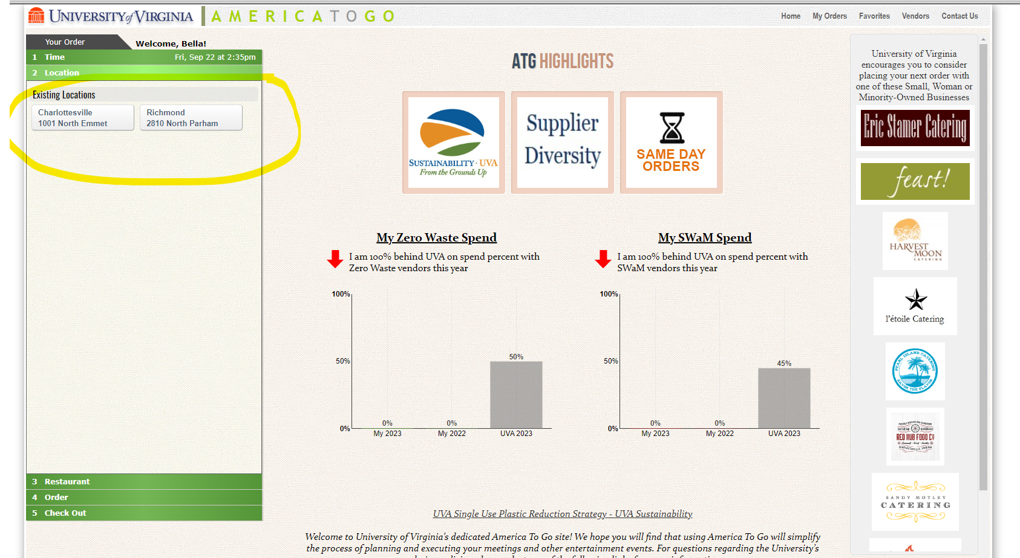
Step 7C: Click your restaurant of choice.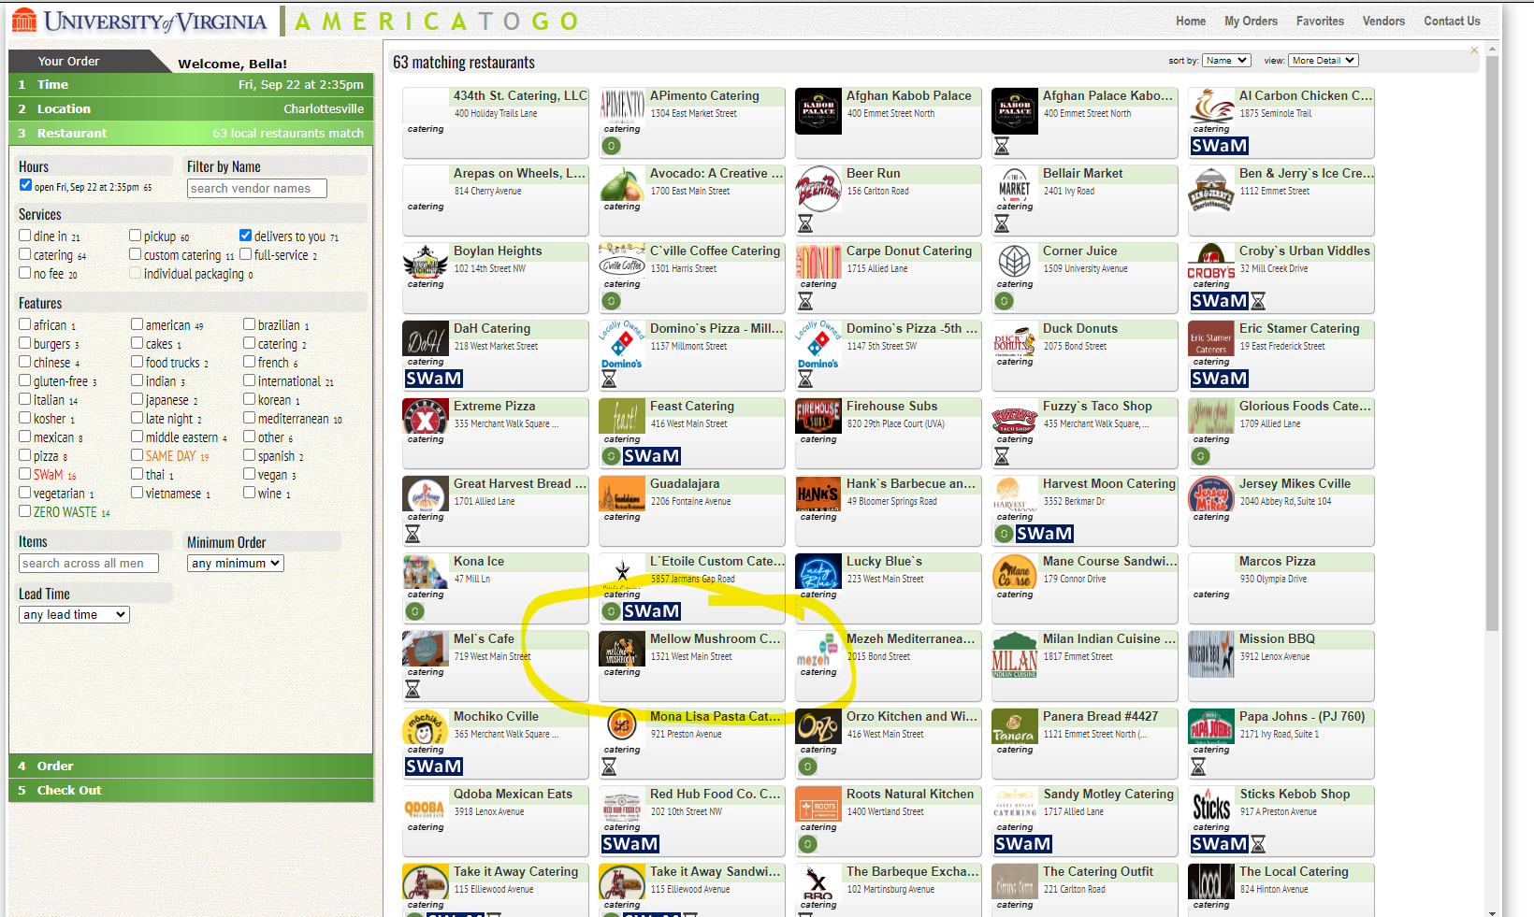

Step 7D: Click the red “Order Now” button.
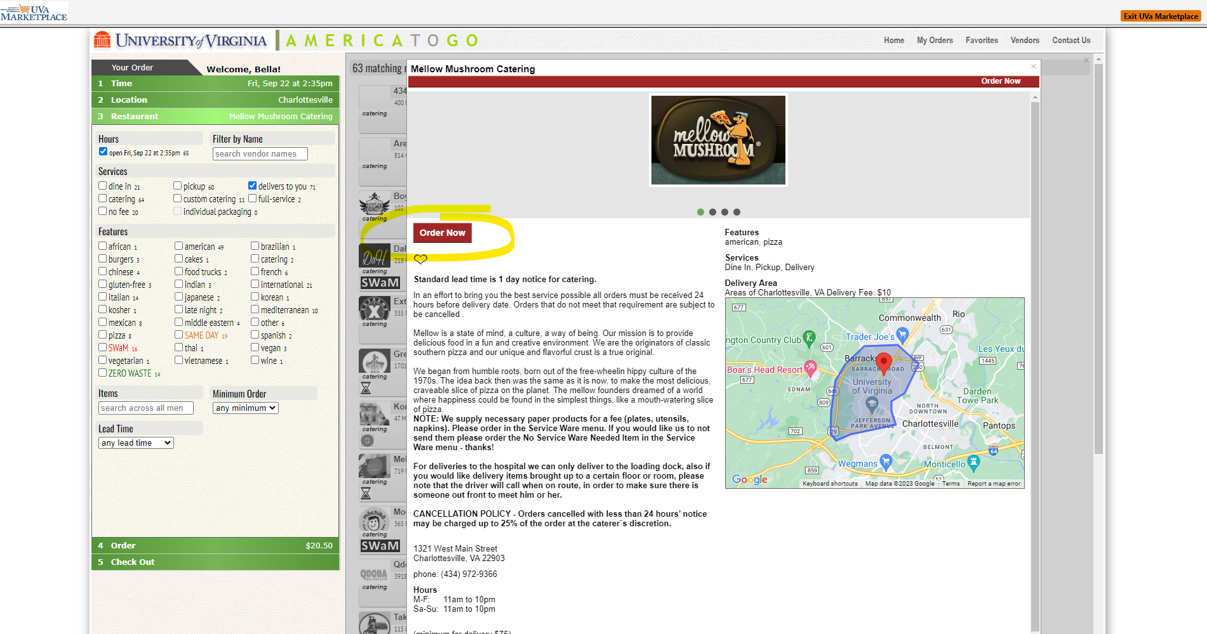

Step 7E: Add your desired items by clicking on the title of each item.
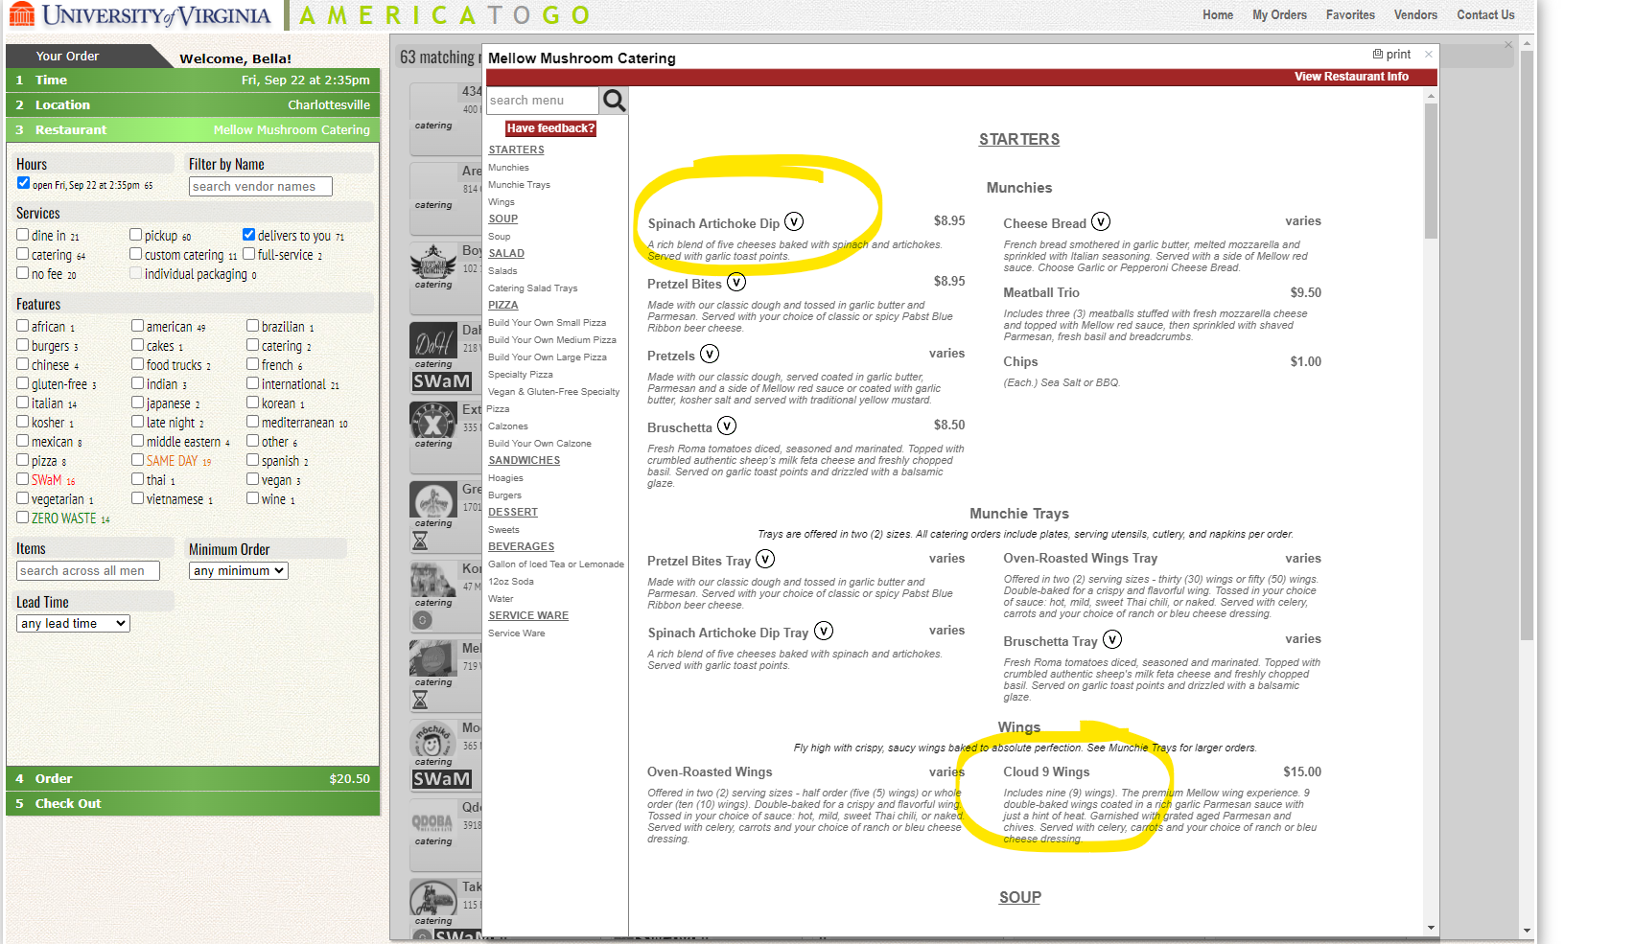

Step 7F: Once you are done adding items to your order, click the red “Check Out” button on the left side.
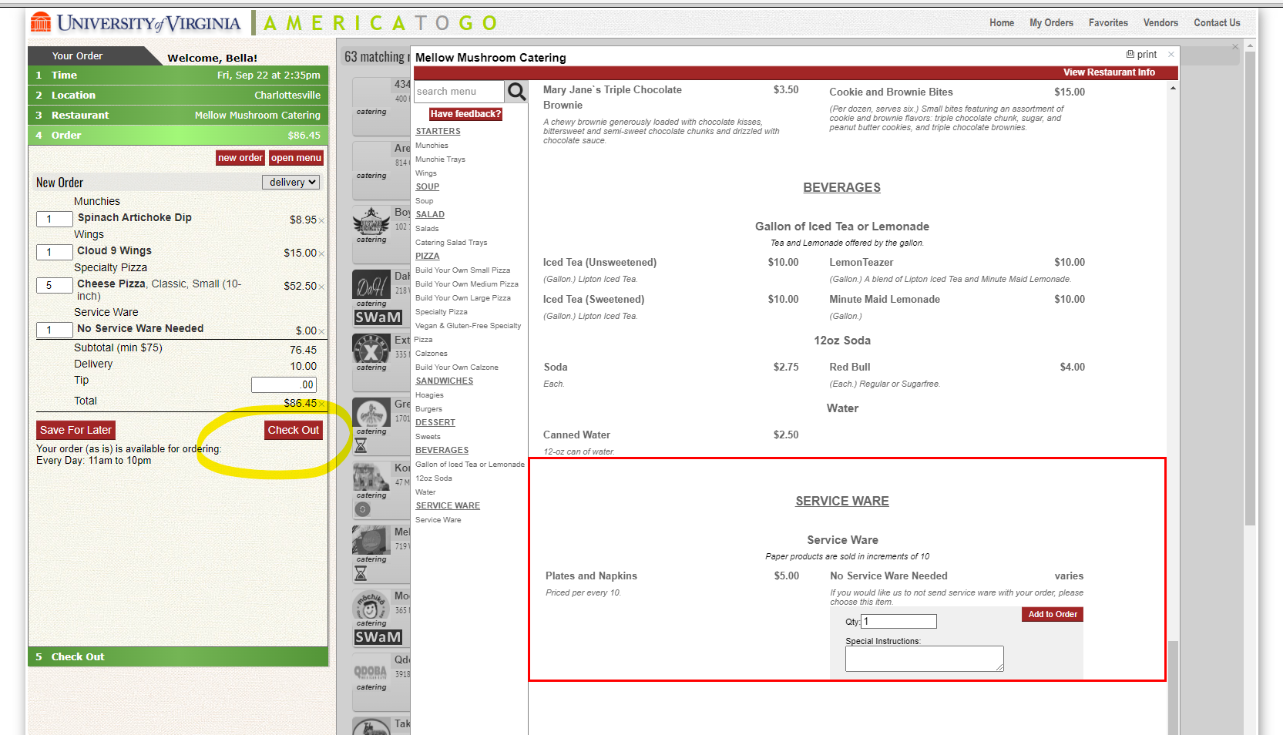
Step 7G: Enter the number of people and business purpose then click the red “Next” button.
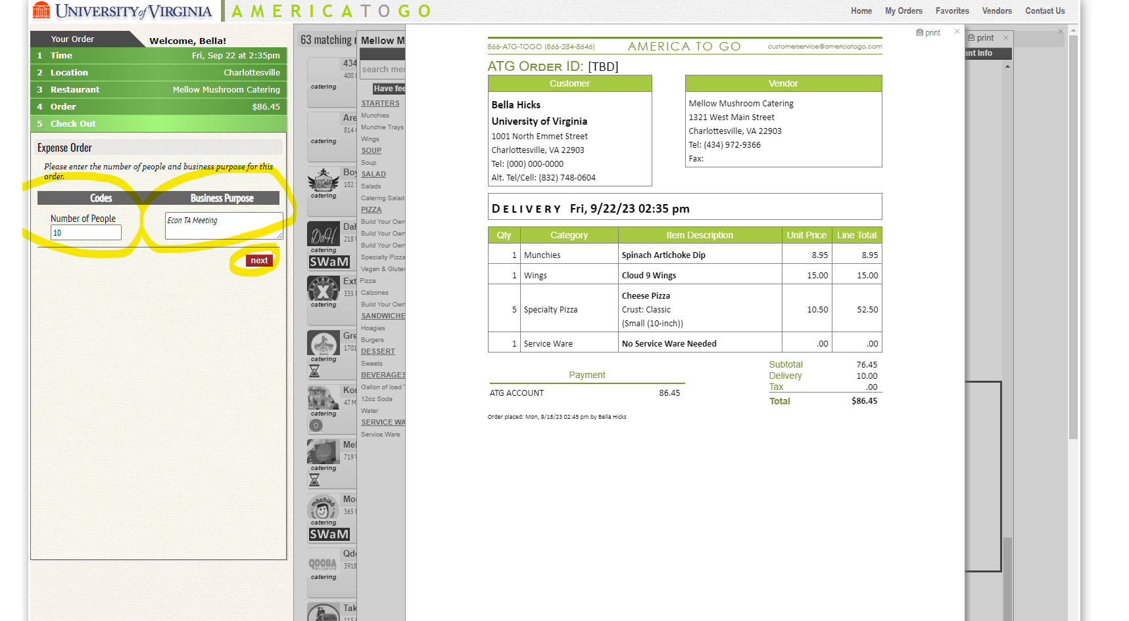

Step 7H: Enter instructions and cell number for delivery then click the red “Next” button.
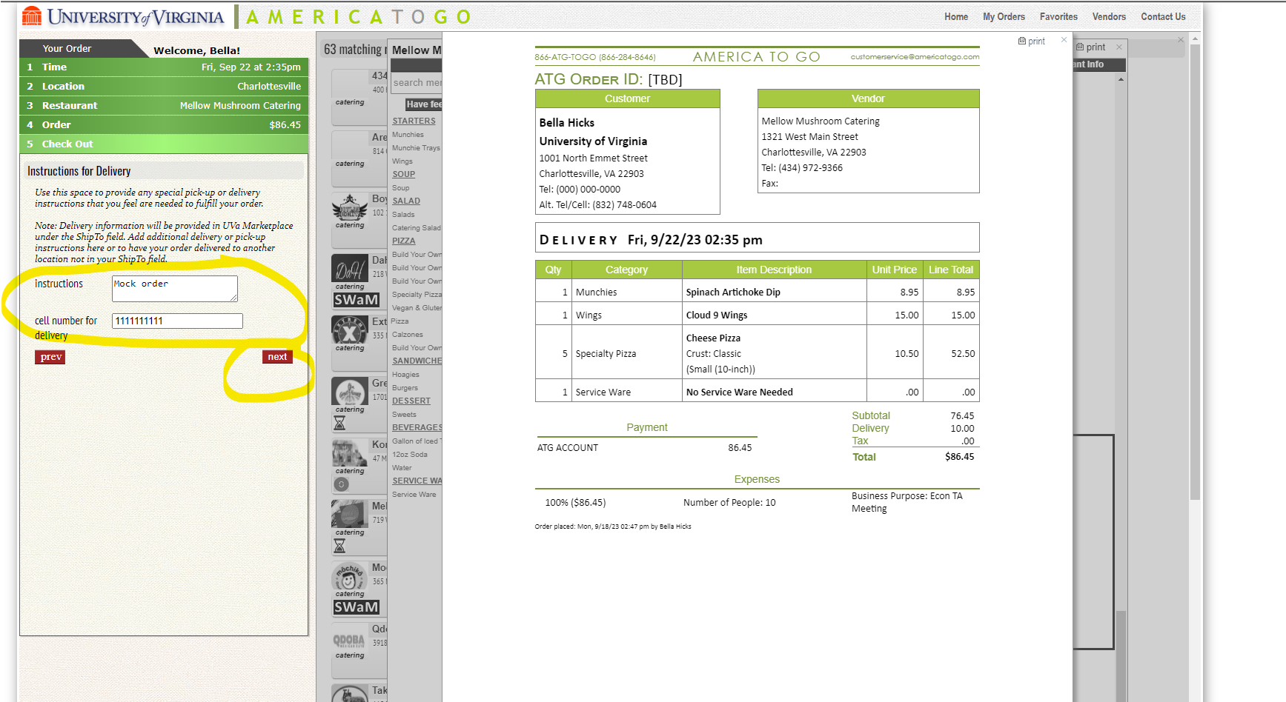

Step 7I: Confirm information then click the red “Next” button.
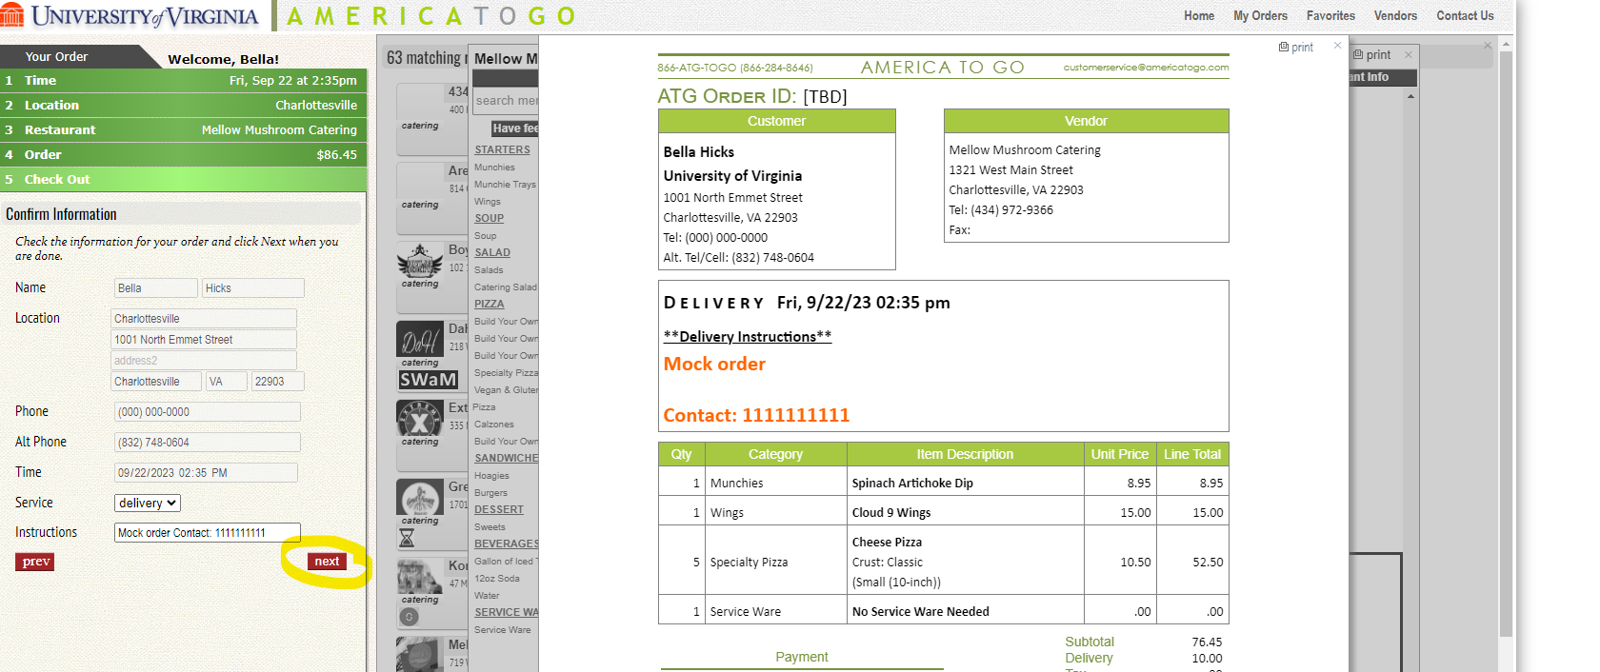

Step 7J: Click the red “Submit now” button.
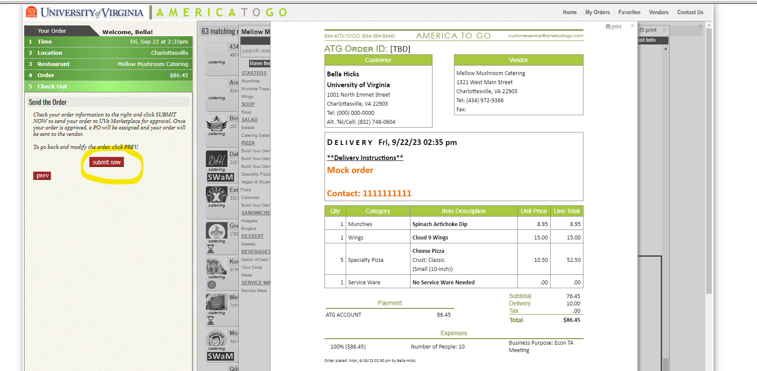

Step 8: Once you have submitted the order (by following the parts to step 7 OR ordering from whichever supplier you chose in Step 6) a new screen will appear. Click the white “Assign Cart” button in the top right of your screen.
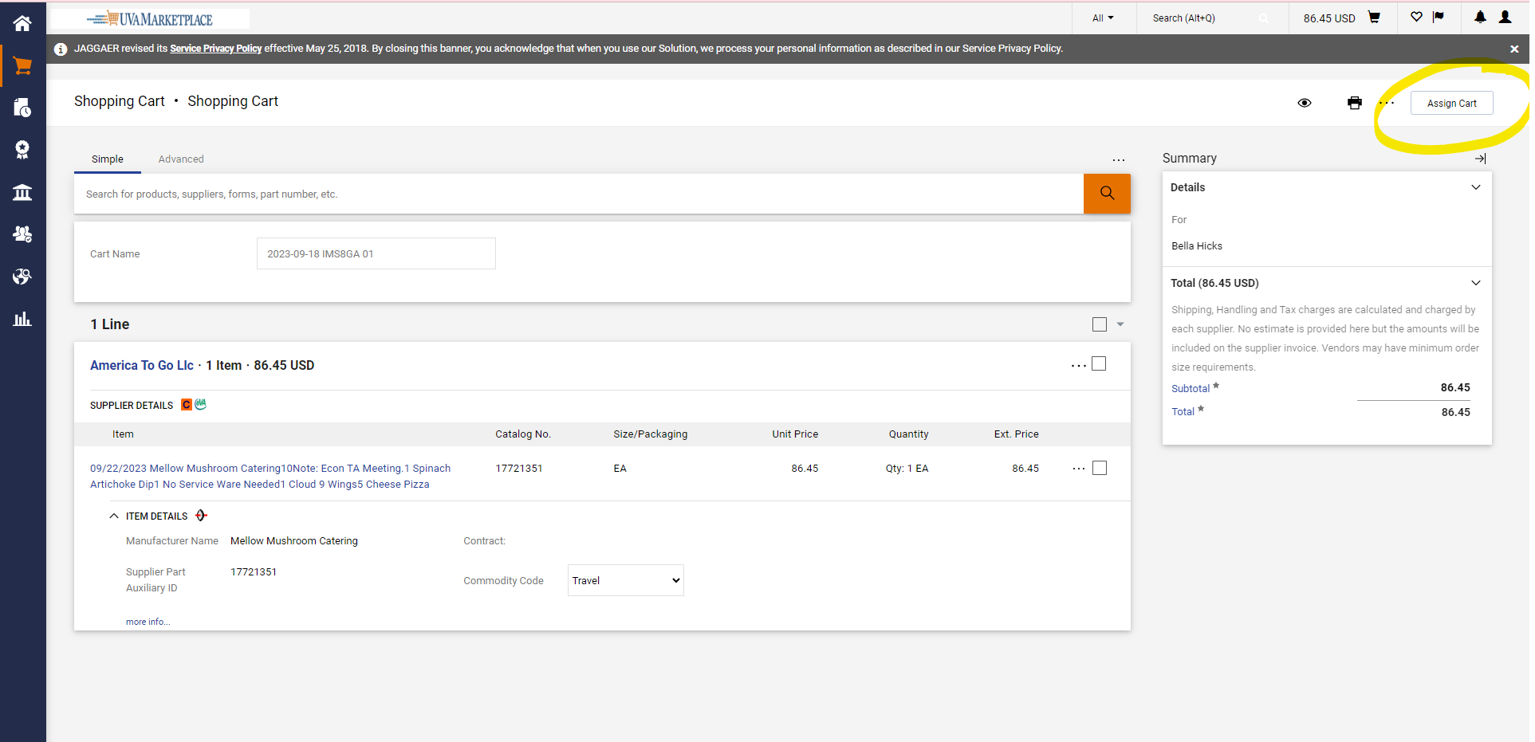

Step 9: Click the blue “SEARCH” button to find your department administrator. For Economics it is Debby Stanford.
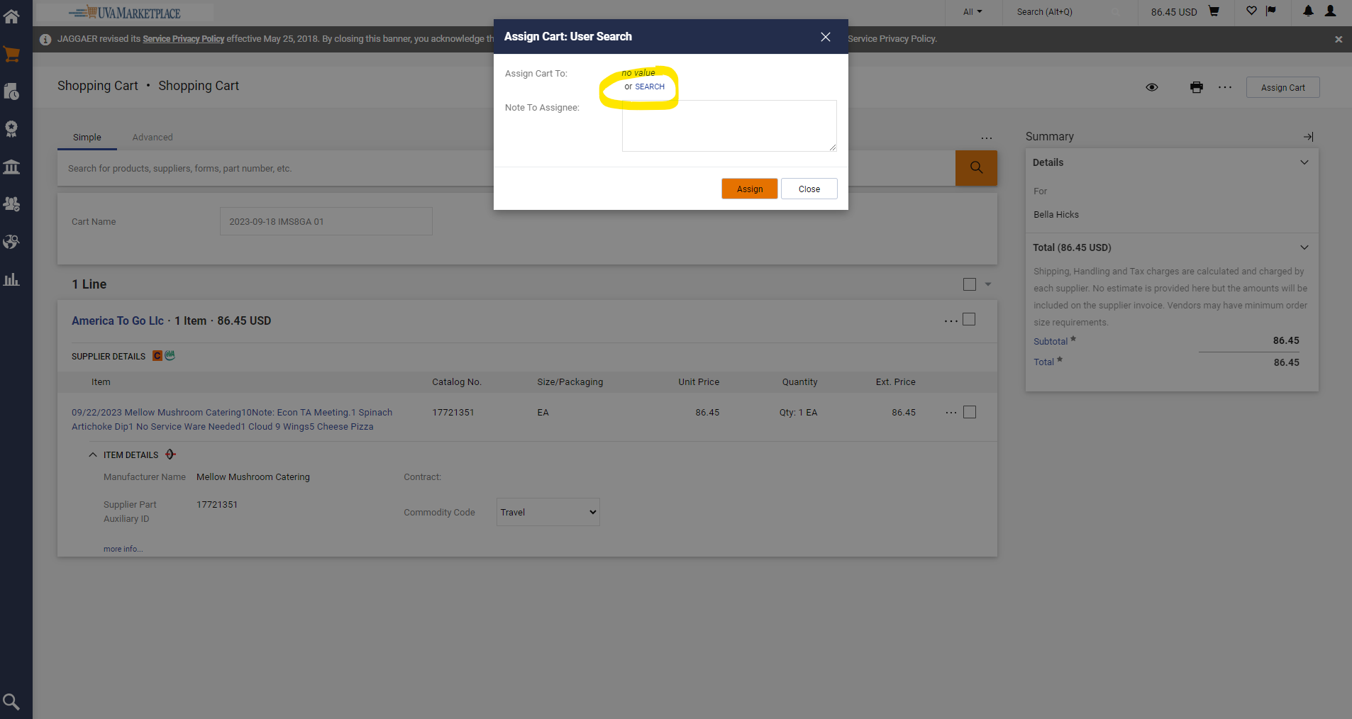

Step 10: Enter in the last name (or other info) about your department administrator, then click the orange “Search” button.
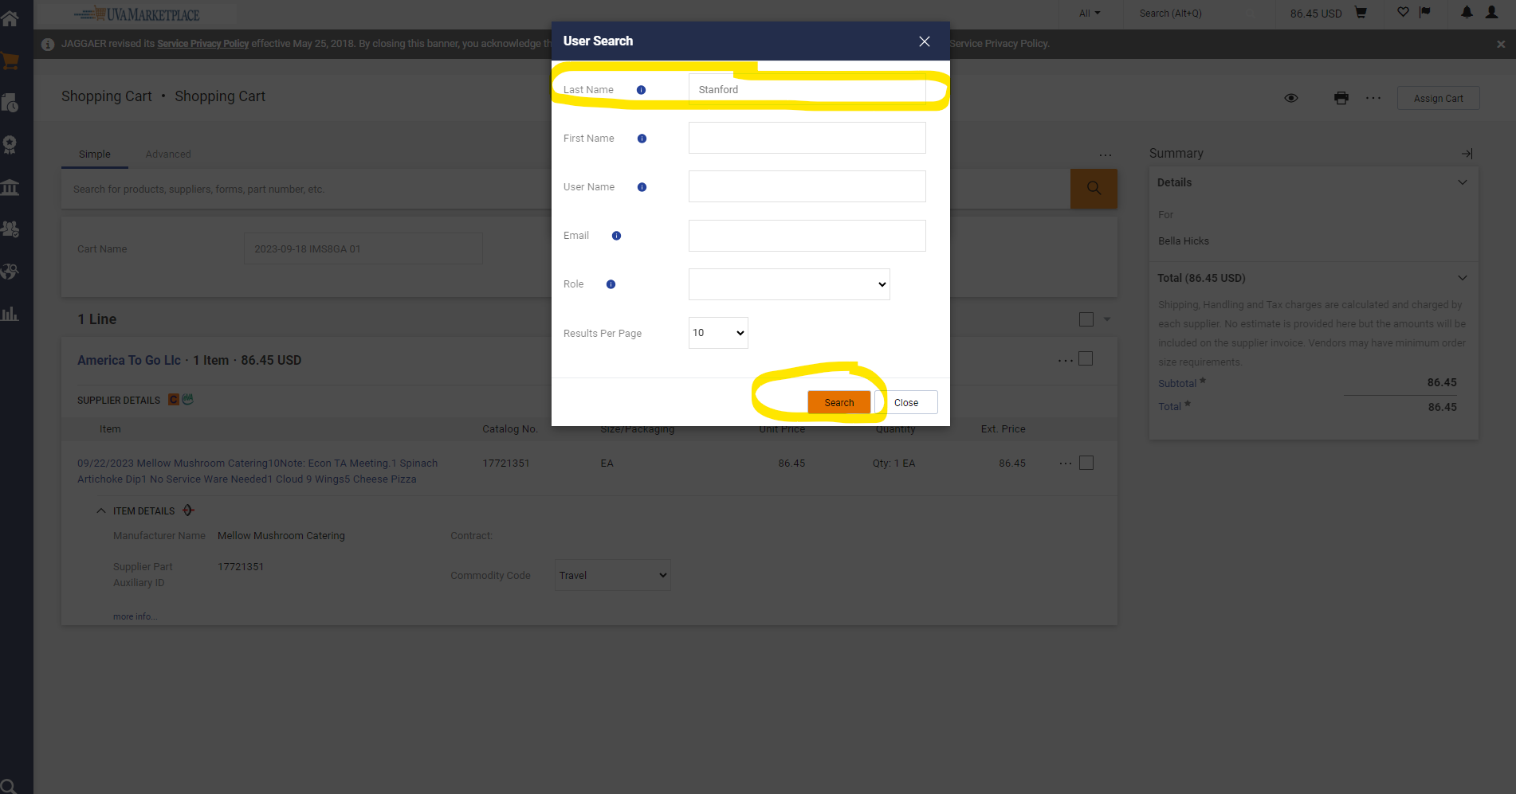

Step 11: A list should be generated, once you find your department administrator in the list, click the + button under the “Action” column.
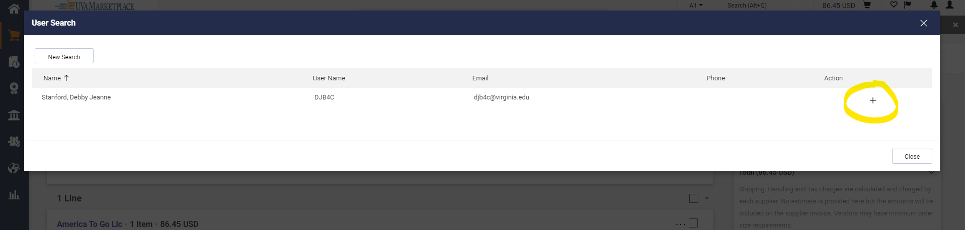

Step 12: In the “Note to Assignee” box add the appropriate Worktag you would like to use then click the orange “Assign” button.
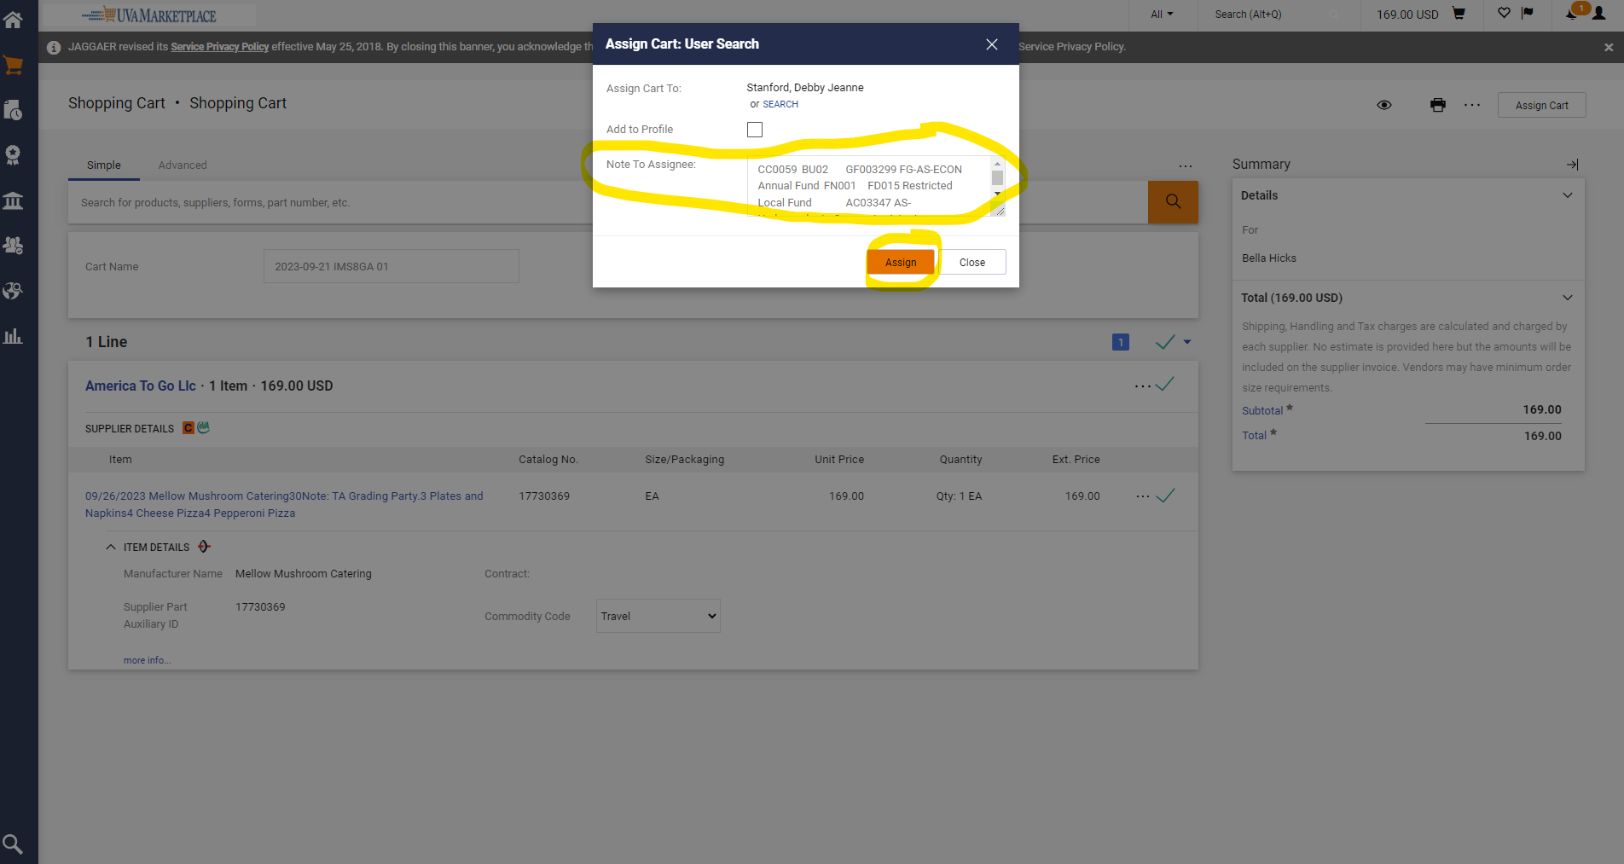

Step 13: Your order should now be assigned to your department administrator. They will make sure everything looks correct and place the order on your behalf.
