Workday Finance Reimbursement Process

Before you submit the reimbursement request in Workday, you’ll need to gather a few things:
- Digital copies of your receipts. If you’re using the Workday app on your phone, you can simply take photos and add them as you go. If you’re using the computer, you can email the photos to yourself.
- The worktags you’ll be charging. Worktags that are ready to use will be highlighted green on your account balance spreadsheet within UVA Box. Please ask Ashley if you have any questions: The worktags are the new account numbers for your accounts (formerly. PTAO).

Gift/Grant/Designated: (GF = Gift; GR = Grant and DN = Designated)
Project: (PJ + 5 numbers)
Cost Center: CC0059 AS-Economics (ECON)
Program: (PG + 5 numbers)
Activity: (AC + 5 numbers)Will be entered under “Additional Worktags”
Assignee: Will be entered under “Additional Worktags”
Business Unit: BU02 AS-Arts and Sciences
Note: All portions of the worktag must be entered on your reimbursement. Please see your account balance spreadsheet within UVA Box for exact account information.

In the Workday search bar, type “create expense report” and press enter. Under search results, click on link to form.
On the Expense Report Information page, you will only update the following fields:
Memo: Please summarize what will be reimbursed. This will show up on financial reporting, so anything that helps Ashley and Debbie confirm the expense was correctly charged. “Books purchased for Mr. Potato’s research,” or “Mr. Potato’s trip to ASSA Conference in Prague July 2022.”
**A note about worktags (see screenshot below). You will not need to fill in all worktag fields. These are the new account numbers, and you can locate your worktags on your account balance spreadsheet.**
Gift/Grant/Designated: You will have one of these. GF###### for Gift; GR###### for Grant; DN###### for Designated.
Fund: should autofill, be sure it matches what is shown on your account balance spreadsheet
Cost Center: should autofill to CC0059 AS-Economics (ECON)
Function: will often autofill after you enter the Gift/Grant/Designated
Additional Worktags: You may be asked to include an Activity or Assignee worktag, and they would be entered here. This field can hold multiple worktags, so no need to delete any that autofill.
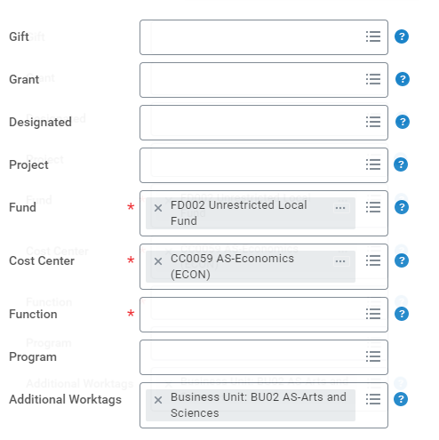
Click OK to go to the next portion, where you will upload receipts.
On the Expense Line page, you will upload each individual receipt and fill in the details.
Upload: upload a single receipt (you’ll add a new page for each receipt)
Date: update to match the date of purchase. (If the date is more than 30 days ago, you’ll likely see a Purchase Justification field at the bottom of the screen, where you should type a simple reason for the delay. “Trip longer than 30 days,” or “Delay getting receipt,” are some examples.)
Expense item: if you type in a search term and press enter, it’ll show you options. For travel, you can search “employee training” and it’ll show you all the available categories.
Total Amount: amount on receipt, and update the currency on the next line if needed.
Memo: more granular then the previous page, something like “train from Paris to Lyon.”
The worktags that you filled in on the previous page should autofill here.
If you have another receipt, click the Add button and upload it on a new screen.
Once you’ve filled in all the details, scroll to the bottom, and click Submit.
(If you get any error messages, and they’re not easy to address, take a screenshot and send it to me for support.)
