EARLY BIRD GETS THE JOB? MARKET UNRAVELING AND OFFER TIMING EFFECTS IN THE POST-BACCALAUREATE LABOR MARKET

by

Kira Flores

Submitted to the Distinguished Majors Program
Department of Economics
University of Virginia
April 30, 2023
Advisor: Sarah Turner
EARLY BIRD GETS THE JOB? MARKET UNRAVELING AND OFFER TIMING EFFECTS IN THE POST-BACCALAUREATE LABOR MARKET

Kira Flores

Abstract

Unraveling describes a labor market where employers extend offers to applicants earlier and earlier, increasing the gap between offer date and employment start date. Unraveling may lead to inefficient matches between firms and applicants and a resulting loss in welfare. National data and data specific to the University of Virginia demonstrate that college graduates, particularly in finance and consulting occupations, are receiving post-baccalaureate job offers earlier in recent years. In 2018, the median month of job offer for graduating students at UVA was February but by 2021, the median month of offer shifted to November of the previous year. The question addressed in this analysis is the extent to which the impact of early offers differs systematically by student gender or race and the extent to which these market forces may have distributional implications that widen or narrow existing salary inequality. I use data from the UVA Career Center’s First Destination Survey for graduating college students to estimate determinants of offer timing and the relationship of offer timing and salary. I find that men accept job offers earlier than women and White and Asian students accept job offers earlier than underrepresented minority students. The results suggest a relationship between offer timing and salary, with earlier offers correlated with higher salaries. The variation in the timeline over which students apply for and receive job offers by demographic group and job search resource utilization also relates to differences in the distribution of starting salaries.

Acknowledgements: I would like to thank my advisor, Sarah Turner, for her guidance through the entire DMP and particularly for her insights, expertise, and suggestions on my thesis. I also thank my DMP cohort, for their support, friendship, and advice. Thank you to Camille Wixon and Gillian Courtney for their input and very helpful advice. Thank you to William Johnson for his expertise and thoughtful consideration. Thank you to my family, friends, and teammates for their love and support always.
Contents

1 Introduction 4
1.1 Introduction 4
1.2 UVA Motivating Evidence 6
2 Background 8
2.1 National Trends in Unraveling 8
2.2 The Market for Entry-Level Undergraduates 9
2.3 Industry Variation – The Case of Consulting and Finance 10
3 Data 11
3.1 Data Source 11
4 Theory of Unraveling 13
4.1 Mechanisms of Unraveling 13
4.2 Characteristics of Unraveling Markets 14
4.3 Social Networks and Unraveling 15
4.4 Demographic Group Differences in Offer Timing 16
5 Model of Job Matching 17
5.1 Firm Maximization 17
5.2 Student Maximization 19
6 Results 20
6.1 Major and Industry Choice 20
6.2 Demographic Effects 22
6.3 Resource Effects 25
6.4 Cohort Effects 26
6.5 Interaction Effects 26
6.6 Salary Effects 28
7 Conclusion 31
References 34
Appendix 36

1 Introduction
1.1 Introduction
Across college campuses, firms are extending job offers to students earlier and earlier. The earliest application deadline for the entry-level position at Bain & Company, a top management consulting firm, was June 25 in 2023 compared to October 26 in 2013 - a change of four months earlier over ten years (My Consulting Offer, 2022; Shipley, 2013). This phenomenon is described as unraveling. Unraveling defines a labor market where offers are extended earlier year to year, offers are dispersed, and often “explode,” or expire, before a candidate has time to consider many other options (Roth and Xing, 1994). Prior research on unraveling labor markets has typically focused on entry-level postgraduate positions, such as medical residencies, gastroenterology fellowships, and summer law associates. The market for entry-level undergraduate positions exhibits many of the characteristics common to unraveling markets, however, it has not previous been the focus of research.
Firms and workers choose to match early to provide a limited guarantee of an outcome. Firms that sign early reduce the risk of losing out if qualified applicants are in short supply. Workers who sign early gain insurance from being shut out of the market if too many qualified applicants appear later. If the gains from insurance outweigh the costs of inefficiency, the existence of unraveling may not pose a problem. However, an early match can also be costly for both firms and workers if the resulting match is inefficient and the costs of unraveling may not be distributed equally across student demographic groups (Roth, 2010). Theory suggests that entry-level labor markets are primed for unraveling. The applicant pool is heterogenous, there is a long training period where applicants acquire skills, and applicants are highly skilled (Li & Rosen, 1998; Fainmesser, 2012). These factors suggest that firms that desire specifically qualified or the best graduating students have an incentive to recruit as early as candidates can be identified with sufficient record of performance, such as a mostly compete transcript, to gain an advantage over competing firms. Students may apply early to signal interest in firms and firms may want to hire interested students to minimize future turnover costs, introducing another incentive for early contracting.
A starting point for this analysis is the empirical evidence and theoretical motivation for unraveling in the entry level BA job market. Figure 1 in the appendix compares the offer timelines between the UVA Classes of 2018 and 2021 reveals compelling evidence of a trend toward earlier offers. Conditional on employment as the first post-graduation outcome, the median month of offer shifted from February for the class of 2018 to November for the class of 2021, a shift of 3 months over 4 years.
Given this “unraveling” of the entry-level baccalaureate market, this analysis asks distributional questions. What types of jobs are matching early? Which students are matching early? Do students who match early have higher starting salaries? Of interest is whether differences in access to information or resources over the course of the undergraduate experience affect these observed patterns. In particular, this paper asks if demographic groups face different frictions during the job search process based on access to information that may affect offer timing. I also explore whether students’ choice of major and/or employment industry account for variation in offer timing by year or demographic group.
Using an OLS analysis on offer timing, I identify a relationship between gender and offer timing: women receive job offers later than men. I find that underrepresented minority groups receive job offers later than white and Asian students. These findings indicate significant variation among demographic groups in the timing that students navigate the job search process. Adding in interaction effects between demographic characteristics and year, I find that unraveling is not widening the gaps in offer timing between demographic groups. The results show that certain job search resources have differing effects on offer timing, indicating that the way students receive information about the job search process correlates to offer timing. Finally, I provide evidence of a significant positive effect for earlier offer timing on salary, indicating that students matching early is correlated with a higher starting salary.
In section 2, I provide relevant background information for unraveling and the entry-level BA market. I describe the data source for the analysis in section 3. In section 4, I introduce theoretical evidence and I outline the theoretical model in section 5. Section 6 reports the results from the empirical model and section 7 presents a conclusion and future considerations.

1.2 UVA Motivating Evidence
The data source for this paper comes from the University of Virginia’s First Destination Survey (FDS). The survey includes self-reported data on post-graduation outcomes for students from the University of Virginia from 2016 to 2022. Students were asked to provide their accepted job offer date and graduation date, from which I generated a measure of offer timing. Results in this analysis are conditional on employment as student’s first destination after graduation and a response for the job offer date and graduation date variables. Figures 1 to 5 provide the motivating evidence for this paper based on this data. The bimodal shape present in all figures indicates two major recruiting periods during a student’s final academic year: the fall and spring immediately preceding graduation. Figure 1 shows a shift from 2018 to 2021 of offer timing moving earlier in the year from the spring before graduation to the fall semester. Figure 2 depicts a growing gap over time between graduation date and offer date. A greater proportion of graduates in the classes of 2020 and 2021 accepted job offers greater than 250 days before graduation, roughly near or before the start of the academic year, while the majority of graduates in the classes of 2018 and 2019 accepted offers around 50 days before graduation. This provides evidence to indicate that the market is unraveling as firms “jump the gun” and offer date unravels from employment start date.
Figures 3 through 5 in the appendix provide evidence that the offer timing varies by demographic group. Figure 3 shows that in the class of 2021, most female students received job offers around 50 days prior to graduation, while a majority of male students received job offers around 250 days prior to graduation. This suggests a significant gap in timing of recruiting by gender when looking at all industries, with female students primarily recruiting for jobs in the spring semester before graduation while male students recruit for jobs a semester earlier. Figure 4 documents a shift towards earlier offer timing that is present for both male and female students. On average, both male and female students graduating in 2021 received job offers earlier than male and female students graduating in 2018. This represents a market wide trend towards earlier offers prevalent among both genders. Figure 5 shows variation exists in offer timing among racial groups. In the class of 2021, White and Asian students received job offers at equal rates between the fall and spring semesters, while Black and Hispanic students skewed towards later offers and other race students skewed towards earlier offers. Given the trend of earlier offers and differences in offer timing by demographic group, this paper explores whether the observed differences in job offer timing for graduating college students tie to specific industries, skills, such as major choice, or behavior in the job search process.

- Background
  - National Trends in Unraveling
The national entry-level baccalaureate market exhibits a similar trend of earlier job offers as seen at the University of Virginia. The timing between job offer acceptance and start date is not tracked at the national level. However, evidence from application deadline changes point towards a nationwide trend. Many firms that recruit nationally have offered earlier application deadlines, and by subsequently earlier offers year to year. National websites that provide guides to students entering the consulting industries warn students to start preparation early, as the first deadlines for full-time roles in 2023 are late June (Mian, 2023). Other career prep websites report gaps of 8 to 12 months between the opening of applications and start dates in consulting (When do consulting firms hire?, 2022). Investment banking prep websites suggest students begin preparing as early as year 1 of college, in anticipation of applying for an internship in year 2 that may be a pathway to a full-time job (Investment Banking Recruitment Guide: The full process, 2022). Other career-oriented sites offer similar guidance to students that recruiting in the engineering, technology, government, healthcare, and advertising industries is expected to begin in late summer and early fall (Northwestern University). While firms may recruit in the spring if they still have need, many firms fill their entry-level positions beginning in the early fall.
Markets unravel when market participants compete for a limited supply of top candidates. While the supply of graduating students is large, not all pursue employment as their first destination and the heterogeneity of the pool of graduates means that there is a dispersal of labor supply across different industries and firms. As such, the labor supply for an individual industry or firm may present as limited. Students have a multitude of firms to apply to but may be constrained by preferences in terms of location, pay, and job function to a much smaller list of options. Therefore, while it may appear that there is a surplus of talent available, the ability of firms and students to connect and preferences on both sides limit the size of the potential applicant pool, creating scarcity that is an incentive to match early.
Another contributor to unraveling at the national level is the level of competition among firms. As firms compete for top talent, they may utilize early exploding offers to contract their preferred candidates. Of the millions of students that graduate each year, a fraction of those attended elite colleges a further fraction possesses the training and desire for certain high demand fields. Career guides for investment banking identify 16 universities as “target” schools for recruiting by investment banking firms (Ting, 2022). This creates scarcity on the supply side for top talent in highly selective and skilled industries. Firms may also have found that the information revealed about a candidate in their last semester of school is not necessary to determine the potential productivity of that worker, so the risk of an inefficient early match decreases and the incentive to contract early increases.
Unraveling may be particularly focused in the finance and consulting sectors. Unraveling tends to occur in markets where the top talent in the labor supply is scarce, leading to competition among firms for the top talent. The smaller the proportion of the most-promising applicants, the more unraveling (Li & Rosen, 1998). While the top investment banking and consulting firms receive thousands of applications, the number of promising applicants is much lower as the firms typically desire students from top undergraduate universities with high GPAs and abundant extracurriculars.

  - The Market for Entry-Level Undergraduates
Around 60 percent of graduates nationally in the class of 2021 pursued employment following graduation (National Association of Colleges and Employers, 2021). During college, students develop skills across a variety of subjects of their choosing and produce a transcript that records their academic record while in school. Beyond academics, many students choose to pursue extracurricular activities like clubs, sports, jobs, or internships while in college. As students approach graduation, many begin to search and apply for employment opportunities based on a variety of factors including job function, industry, location, and salary.
Firms often look to hire college graduates to fill entry-level positions; half of employers’ full-time entry level hires in 2017 were recent college graduates (Koc et. al, 2017). Recruiting timelines and processes vary by industry and firm but typically occur in a student’s final academic year. Firms solicit applications on company websites, job boards like LinkedIn or Handshake, and appeal directly to students at in-person events like career fairs. Applications are accepted on a rolling basis, where applicants can apply at any time and offers are extended asynchronously, or with fixed deadlines, where all applications are reviewed and offers extended at the same time. Firms evaluate students along a variety of criteria including GPA, major, previous work experience, extracurriculars, and interview performance.

  - Industry Variation – The Case of Consulting and Finance
There is substantial variation across industries and firms. Industries differ in job function, salary range, recruiting timeline, application process, and competitiveness among other differences. The consulting and investment banking industries are known to be two of the most competitive in recruiting, potentially leading to faster unraveling in these sectors. The consulting and investment banking labor markets clear among the earliest for entry level positions. Recruiting for full-time positions in both industries begin over the summer before a student’s final year. A significant number of entry-level positions are filled from previous junior summer internships, further accelerating the recruiting timeline to sophomore year for junior year internships and increasing competition for the remaining open positions. When the proportion of the most promising applicants is low, firms must compete for their preferred candidates and may use early offers as a tool. Acceptance rates to the top consulting and investment banking firms hover around 1 to 2 percent. JP Morgan reported 54,000 applicants for its 480 investment banking positions, accepting 0.89 percent of applicants in 2022 (Davies, 2022). While top investment banking and consulting firms receive a surplus of applications, there is intense competition among firms for the very top of the applicant pool. They attract high-performing students interested in business and finance and offer large salaries and prestigious reputations. Application deadlines move weeks earlier each year; firms that can get a head start on recruiting can look to lock up top talent by extending early exploding offers. Full-time offers derived from a previous year internship are also common in these industries, creating an earlier round of recruiting and job offers that clears 1.5 to 2 years before full-time employment start dates.

- Data
  - Data Source
The main data source used for this empirical analysis comes from the University of Virginia Career Services First Destination Survey (FDS). The source contains information collected from University of Virginia graduates in the years 2017 to 2022 following completion of an undergraduate degree. The survey is distributed by the University of Virginia Career Center to students in the semester prior to graduation and is open until December 31st of the student’s graduating year. This analysis is restricted to the years 2018 to 2021 based on response rate for key variables. The unit of observation is student, and the analysis contains 20,583 observations. The data includes information on student school, major, graduation date, offer date, graduation outcome, industry, salary, and pathway of job search. Table A.1 summarizes the key variables of interest for the complete dataset and the subset of the dataset analyzed in this paper. Of the 20,583 observations, 29 percent contained the necessary offer timing information to be included in the analysis.
The key variable of interest, offer timing, is calculated by taking the difference between a student’s offer date and a student’s graduation date and is measured in days. Offer timing was also measured using a dichotomous categorical variable with categories of students receiving a job offer before their 4th year or after the start of their 4th year. The dichotomous categorical variable for offer timing was calculated by first sorting offer dates into one of three terms throughout each year, i.e., spring 2017, summer 2017, fall 2017. Graduation dates were sorted into four categories for year, i.e., spring 2017, spring 2018. These categories were used to calculate the number of terms between graduation and offer date. If the number of terms between graduation and offer was less than or equal to two, the student was classified as accepting an offer “after the start of their 4th year.” If the number of terms between graduation and offer was greater than two, the student was classified as accepting an offer “before the start of their 4th year.”
As a self-reported survey, there is a potential for bias in response content and survey participation. This is of particular concern if there are demographic differences in response rate or in accuracy of reported data. Survey questions changed in wording and response choices over the period measured, however the differences are not expected to change results. One limitation to the dataset is the lack of a variable to control for academic performance or extracurricular activities that may affect the timing of a job offer. Research on GPA differences by gender reveal that women typically have slightly higher GPAs on average (Conger & Long, 2010). if we assume that a higher GPA is beneficial to labor market success, the omission of this variable may bias our estimation of offer timing. This likely biases our estimates for women downward, making the reported estimates the upper bound of differences between men and women.
I argue the University of Virginia is representative of the national market for undergraduates. The University of Virginia is a public four-year flagship university located in Charlottesville, Virginia with undergraduate enrollment of 17,000. As a public state university, 68 percent of students are residents of the state of Virginia with the remainder coming from out-of-state or international. The University of Virginia has a diverse student body in terms of both gender and ethnicity. From the classes of 2016 to 2021, 69.73 percent reported working as their outcome after graduation in a variety of industries such as internet and software, K-12 education, and healthcare. Many large companies and organizations recruit on the University of Virginia campus or through the University of Virginia’s Handshake portal. The University of Virginia is representative of other four-year universities, offering a broad range of majors to a diverse student body that pursues a variety of outcomes after graduation.

- Theory of Unraveling
4.1 Mechanisms of Unraveling
Unraveling in a labor market occurs in the following way. On the applicant side, students apply to any number of positions they desire and receive or do not receive offers. Because offers for different positions are not received synchronously, the student must then decide whether to accept an early job offer or to wait for a different option later. Students may accept an early offer to provide a limited guarantee that they will not end up without a job or in a sub-optimal job at the end of the job search process (Li & Rosen, 1998). On the firm side, employers receive applications and may choose to extend or not to extend an offer to the applicant. Many employers extend offers on a rolling basis or have multiple application deadlines. As a result, employers may find that not all of the applicants they prefer are available at the time that employer decides to extend an offer (Roth & Xing, 1994). Firms may extend offers earlier to secure commitment top candidates. Year to year, this creates a cycle where firms continuously push earlier offers to gain an edge and students accept the early offers to secure job. As a result, appointment date unravels well before expected employment start date and before the student has completed their degree.

  - Characteristics of Unraveling Markets
The job market for entry-level undergraduates comprises the characteristics of markets that are unraveling. Li and Rosen (1998) identify two identifiable aspects of unraveling. First, unraveling occurs when participants compete for a limited supply of the best candidates or positions and “jump the gun” to gain an advantage. Second, unraveling of the appointment date involves the occurrence of the appointment date unraveling years before participants finish qualifications. Both aspects are consistent with the undergraduate entry level labor market. Fainmesser (2012) identifies three common characteristics of markets that experience unraveling: (1) candidates undergo a long training period during which they acquire skills; (2) workers in the market are highly skilled; (3) employment offers are open for a short duration and acceptance of an offer is acknowledged as a binding commitment (Fainmesser, 2013). All three of these characteristics are consistent with the entry-level BA job market. (1) Long training period: The standard college curriculum is designed to be completed in four years; at the University of Virginia, 82 percent of students graduate in four years (Graduation Rates). (2) Highly skilled workers: most UVA graduates enter industries that demand highly skilled workers. The top industry destinations for 2020 UVA graduates include: internet and software, K-12 education, healthcare, investment banking, and management consulting (UVA Class of 2020). (3) Employment offers are “exploding”: although the type of offer is not publicly disclosed by the UVA career center, anecdotal evidence supports that many employers extend “exploding” offers to graduating students. Job offers are typically a contract which students regard as binding, although penalties for reneging on a signed offer vary by industry and firm.

  - Social Networks and Unraveling
Prior research by Fainmesser (2012) revealed a connection between social networks and unraveling and introduced a model of unraveling considering social connection. In the model, workers can convey additional information about their own ability to firms through social connections. These social connections allow firms to hire early and dilute the talent pool in later stages of recruiting. Findings indicate that increasing the networks span, or the number of workers and firms with at least one social connection, always increases unraveling. Evidence from Li and Rosen (1998) supports Fainmesser’s model, finding that if worker productivity is revealed to firms, unraveling occurs among the most promising applicants. In this paper, I use data on the job search resource used as a measure of social connection. Three job search resources rely on a level of social connection: Alumni, Faculty, Family/Friends/Other. I hypothesize that students receiving a job offer through a job search resource based on social connection benefit from receiving information about the application process or their match to a firm. Based on Fainmesser’s theory, student’s using a job search resource based on social connection may receive job offer earlier if they can convey their productivity to the firm through the social connection.

  - Demographic Group Differences in Offer Timing
Empirical evidence suggests that there are significant differences in the ways that different demographic groups approach the job search process and as a result, have different outcomes in terms of offer timing. Cortes et al. (2022) looked at a population of undergraduate business school graduates and found that women accept job offers earlier than men due to greater risk-aversion for women and over-optimism in men about future offers. Their research also revealed a statistically significant effect of offer timing on salary; accepting a job later after graduation led to a lower salary. Research by Green et al. (1999) found racial differences in job search strategies. Their research did not address offer timing but stated that racial groups utilize different job search strategies and utilize the same strategies to different effects in terms of sorting into occupations. This prior research suggests that demographic groups navigate the job search process differently and those differences result in meaningful differences in post-graduation outcome.
Observed differences in offer timing between demographic groups may be the result of membership in groups that provide access to networks beneficial in the job search process. If membership in clubs during college varies among demographic group, certain students may be advantaged in the job search process through access to networks or information. Prior research has shown that major choice in college and employment industry choice after college is correlated with demographic group due to differences in preferences, such as those related to coursework or potential monetary payoffs for different majors (Dickson, 2010; Zafar, 2013). Demographic groups likely enter the job search process with different preferences of outcome and different levels of access to information about the job search process, potentially contributing to observed differences in offer timing.

- Model of Job Matching
5.1 Firm Maximization
Observable characteristics contribute to unraveling and earlier offer timing as firms and students face incentives and costs to matching in different periods. For this model, I present a two-period matching model where period 1 is a period of early matching and period 2 is a period of “normal” matching.
Firms look to maximize profit by hiring the best fit workers. Workers that possess the industry relevant skills that provide the best fit for a firm are strong candidates that are identified as type $α$; workers that possess non-coveted skills to the firm are identified as type $β$. If firms believe that the probability of hiring a strong candidate is higher the earlier they recruit, the firm will extend earlier offers.
$$\max_{ο} π_{i} \left(ρ\left(c\right)\left(ο*z_{j}\left(α\right)*η\right)+\left(1-ρ\left(c\right)\right)\left(ο*z_{j}\left(β\right)*η\right)\right)$$
Firms maximize profit by hiring workers (j) with coveted, industry relevant skills [($z_{j}(α)$] and a general human capital level of η. Firms choose to extend offers $ο$ to workers. Coveted skills may be technical knowledge relevant to the industry or coursework in a relevant major. Non-coveted skills may be technical knowledge or previous coursework in an unrelated field. There are significant gender and ethnic differences in choice of major in college. As a result, the proportion of students with coveted and non-coveted skills may differ by gender or ethnicity and the differences vary by the industry of interest. η encompasses non-firm-specific human capital.
The probability that a firm will hire a type $α$ worker in period 1 is $ρ$. Firms that hire workers without industry-relevant skills [$z_{j}\left(β\right)$] face a cost from the mismatch with a probability of 1 – $ρ$ in period 1. The presence of a social connection (c) increases the probability of a match with a type $α$ worker. If firms and students can be “connected” through a mutual, personal connection in period 1, firms can increase the probability of hiring a type $α$ worker through greater information about the skills or fit of the potential student.
I assume that there are fewer students with coveted skills than without. Students at college can specialize in many different fields, meaning that the proportion of students with coveted skills in any specific field is smaller than the proportion of students that studied a different field. Firms know that the proportion of strong candidates is limited, introducing an incentive to match early in case there are fewer or no strong candidates in the applicant pool later.
$$Z_{α,i}< Z_{β,i}$$
Where $Z_{α}$ is the proportion of students graduating with coveted skills for firm i and $Z_{β}$ is the proportion of students graduating with non-coveted skills for firm i.
Firms believe that competition for type $α$ workers will be intense in period 1, as all firms attempt to recruit the strongest candidates. As a result, the firm believes in period 2 that the probability of hiring a type $α$ worker has decreased and the probability of hiring a type $β$ worker has increased, as early hiring has diluted the top of the candidate pool: $ρ_{1}>ρ_{2}$. As a result, firms have an incentive to make offers to workers in period 1, to increase the probability of a match with a type $α$ worker that will maximize profits.

5.2 Student Maximization
Students look to maximize utility by working for a firm with higher prestige, better match to their interest and skills, and a high salary. If students believe that the applicant pool will be stronger in the future, there is an incentive to seek an earlier offer.
$$\max_{ο}u_{j}\left(σ\left({ο*θ}_{i}*τ_{i}* δ_{ij}(θ,τ)\right)+\left(1-σ\right)\left({ο*Θ}_{i}*Τ_{i}*δ_{ij}(Θ,Τ)*Κ\left(x_{j}w_{j}\right)\right)\right)$$
Students maximize utility by accepting a job offer, $ο$, with a probability of $σ$ in period 1 from a prestigious firm ($θ_{i})$, by receiving an offer from a firm that matches with their interests ($τ_{i}$) and ceteris paribus, students prefer a higher salary ($δ_{ij})$ to a lower salary. Students face a cost with a probability of $\left(1-σ\right)$ in period 1 of receiving an offer from a non-prestigious firm ($Θ_{i}$) or receiving an offer from a firm outside of their interest ($Τ_{i})$ in period 1. $Κ\left(x_{j}w_{j}\right)$ is a search cost associated with the job search process where $x_{j}$ is access to information about the market for student j and $w_{j}$ is prior internships or work activities that help in the job search process. An increase in $x_{j}$ or $w_{j}$ decreases search costs K. To match early, students must acquire information about how the market works. Information may be tied to resources available during the job search process or to prior activities (i.e. internships, clubs). Students may differ in x and w based on demographic groups. Access to a social connection in the target field may increase a student’s level of information about the job search process.
Students believe that the probability ($σ)$ of a utility maximizing match with a prestigious firm and a firm that matches their interests, is higher in period 1 than in period 2 as the applicant pool is stronger in period 2 when more students are ready to apply: $σ_{1}>σ_{2}$. A student has an incentive to apply to and accept a job in period 1, when the probability of an efficient match and utility maximization is higher.
The model implies that job offer timing varies by scarcity of firms or students, firm type, and student skills, information access, and preferences. The model is consistent with variation in offer timing by industry, as industries face different sized applicant pools and proportions of strong candidates that determine the incentives for early matching. On the student side, the model predicts that group differences in skills, access to information, and prior work experience will affect job offer timing, motivating the following analysis of demographics, industry, job search resource, and offer timing. The model provides a basis for an analysis on salary by implying that earlier offers come with higher salaries.

- Results
In the following section I use OLS regression techniques to test differences in offer timing along demographics, graduation cohort, industry, and job search resource. Theory suggests that students in demographic groups navigate the job search process differently which could result in significant differences in job offer timing. I use an analysis of graduation cohort to test for earlier offers year to year as evidence of unraveling in the entry-level BA market. Analysis of the job search resource variable provides insight into the role of information access and social connection in offer timing. Finally, I test for correlations between job offer timing and salary to see if the timing when students receive a job offer can explain some of the observed differences in salary.

6.1 Major and Industry Choice
Choice of employment industry is a strong correlate of offer timing. Industries are known to recruit different times during the academic year. The following OLS results indicate that students in the consulting, financial services, and retail/consumer products industries match significantly earlier. This finding is consistent with observed national trends that suggest the consulting and finance industries recruit the earliest. Legal, marketing/media, and non-profit industries match the latest. Student major and employment industry are likely correlated as major represents skills relevant to specific industries and choice of major can be an indication of preference for a specific field and related industries. Observed industry outcome may be the result of a choice prior to the job search or an outcome from the job search. For the purposes of this analysis, I assume industry is chosen before the job search process and control for industry fixed effects to examine differences in timing and salary independent of industry sorting. Controlling for major fixed effects rather than industry fixed effects did not meaningfully change the estimates for cohort, demographic, or job search resource effects.
Student industry outcome choice may vary by demographic group and affect both offer timing and salary. The remaining gap in salary between men and women is often attributed to differences in career aspirations by gender and greater career discontinuity for women (Sloane et al., 2021; Bertrand et al., 2010; Fadlon et al., 2022). Tables A.2 and A.3 provide some evidence to support the first of these two potential explanations. Women are overrepresented in humanities, education, and interdisciplinary majors as well as education, legal and law enforcement, and non-profit industries. Average annual salary in above listed majors ranges from $44,000 and $53,000 while average salary in the above listed industries ranges from $38,000 to $49,000. Men are overrepresented in commerce, engineering, and mathematics majors with average annual salary ranging from $68,000 to $83,000. Men are also overrepresented in defense, financial services, and technology and software industries with average annual salaries ranging from $77,000 to $87,000. This evidence suggests that differing career aspirations contribute to variation in major selection in college and in jobs pursued after graduation by gender and manifest in different starting salaries between men and women.

6.2 Demographic Effects
My first estimation on offer timing with demographic groups is as follows:
$$y_{i}= β_{0}+ {β_{c}X_{i,c}+ β}_{2}{gender}_{i}+ β_{3}{black hispanic}_{i}+ β_{4}{other race}_{i}+β_{n}δ_{i,n}+ β_{r}θ_{i,r}+ ε_{i}$$
where $y_{i}$ is the difference between offer date and graduation date in days of student (i). $X_{i,c}$ are dummy variables for graduation cohort for student i in cohort c. ${gender}_{i}$ is a dummy variable that equals 1 if the student is male. ${black hispanic}_{i}$ is a dummy variable that equals 1 if the student is Black or Hispanic and ${other race}_{i}$ is a dummy variable that equals 1 if the student is categorized as “other” race. $δ_{i,n}$ are dummy variables for each industry, n. $θ_{i,r}$ are dummy variables for each job search resource, r. In this model, $β_{2}$represents the difference in offer timing in days between the male and female students; a positive $β_{2}$ indicates that male students accept offers $β_{1}$days earlier than female students. $β_{3}$ and $β_{4}$ represent the difference in offer timing between Black/Hispanic students and other race students respectively compared to white students.

Table B.1: Timing of Job Acceptance
 | Dependent Variable: Offer Timing (continuous)
 | OLS
 | (1) | (2) | (3) | (4)
2019 | 17.84*** | 17.29*** | 16.64*** | 16.00***
 | (5.478) | (5.471) | (5.378) | (5.008)
2020 | 42.92*** | 42.25*** | 33.70*** | 37.24***
 | (5.538) | (5.528) | (5.500) | (6.010)
2021 | 57.64*** | 56.56*** | 47.82*** | 53.96***
 | (5.735) | (5.724) | (5.687) | (6.292)
Male |  | 23.77*** | 7.701* | 8.483*
 |  | (4.115) | (4.231) | (4.430)
Black/Hispanic |  | -14.50** | -10.41 | -12.28*
 |  | (6.763) | (6.636) | (7.090)
Other Race |  | -11.78** | -13.67** | -18.41***
 |  | (5.562) | (5.382) | (5.339)
Alumni |  |  |  | 12.03
 |  |  |  | (8.086)
Career Fair |  |  |  | 70.76***
 |  |  |  | (6.879)
Faculty |  |  |  | 15.15
 |  |  |  | (12.76)
Family/Friends/Other |  |  |  | 41.67***
 |  |  |  | (7.274)
Handshake |  |  |  | 39.79***
 |  |  |  | (6.382)
Other |  |  |  | 46.12***
 |  |  |  | (8.842)
Previous Employment |  |  |  | 89.90***
 |  |  |  | (10.72)
Industry FE |  |  | X | X
Constant | 103.2*** | 96.31*** | 153.3*** | 158.5***
 | (3.490) | (4.097) | (5.499) | (5.654)
Observations | 5,927 | 5,927 | 5,927 | 5,927
R-squared | 0.020 | 0.027 | 0.086 | 0.086
Robust standard errors in parentheses. *** p<0.01, ** p<0.05, * p<0.1.
Note: Offer timing (continuous) is a numerical continuous variable measuring the difference between graduation date and offer date. A positive coefficient indicates an offer before graduation. Omitted variable for job search resource is advertisement/online resource. Industry controls include fixed effects for 16 industry groups. Observations with a value of grad_offer greater than 1200 were excluded.

Table B.1 reports the OLS fixed effects regression results of gender and ethnicity on job offer timing. Columns (2), (3), (4) reveal that there are significant effects of gender and ethnic groups on job offer timing robust to the inclusion of graduation cohort, job search resource, and industry. All regression specifications indicate that male students accept job offers earlier than female students. This finding is inconsistent with prior research done by Cortes et al., who found that women are more likely to accept an earlier offer due to greater levels of risk aversion and less overconfidence compared to men that they will receive a later offer. This result may suggest a systemic difference in the way students of different genders navigate the job search or are treated in the job search process. The residual gap in offer timing by gender may be attributable to lower confidence in women in applying for jobs, rather than overconfidence in job acceptance. Women hesitate to apply to jobs if they do not meet all the qualifications (Mohr, 2014). Thus, women may apply later for the same position to provide a more complete application. This explanation would be consistent with the Cortes et al. findings that men are more confident in job search; however, overconfidence may manifest in different behavior in application timing compared to offer acceptance timing. Men may choose to accept the first offer while women wait to review other potential options. Similar usage of job search resources by both men and women suggests that information in the job search process may not be a barrier present between genders.
We also find robust ethnicity effects controlling for industry, graduation cohort, and resource; Black and Hispanic students and other race students receive job offers later than White students. We hypothesize that this gap in offer timing is attributable to student achievement in college and how students use the job search resources. Prior research indicates sizeable racial differences in college achievement, suggesting that earlier offers for White and Asian students may be due to better performance in college (Fletcher & Tienda, 2010). Research also indicates differences in job search strategies among different racial groups. Our dataset reported similar usage rates by racial group of job search resources; however, racial groups could use the same resource to sort into different occupations or industries. Green et al. (1998) found that Hispanics use informal, social job search strategies to sort into lower-paying jobs while Whites use those same strategies to sort into higher-paying jobs.

6.3 Resource Effects
Column (4) reports the results of a specification including the novel measure of job search resource. This specification serves as a measure of information access during the job search process for students. Reported coefficients are in comparison to advertising/online resource. The results suggest that previous employment is correlated with earlier offer timing; this is consistent with the understanding that prior internships are a common pathway to full-time employment and offer both firms and students greater information about the other party, allowing for an earlier offer to be made. The “Family/Friends/Other” job resource serves as the best proxy for the role of social connection in offer timing. The results in Column (4) indicate that receiving a job offer through a Family/Friends/Other social connection corresponds to significantly earlier offer timing. Social connection may accelerate the offer process by providing the student with greater information about the application process and providing the firm with greater information about the potential applicant. Social connection through faculty does not appear to be a strong correlate of earlier offers; however, faculty connections are likely particularly relevant in academic positions, where recruiting is done later than in the private sector industries.

6.4 Cohort Effects
Columns (1) to (4) demonstrate robust correlations between graduation cohort and earlier offer timing. There are significant effects on offer timing for 2019, 2020, and 2021 graduation cohorts compared to the 2018 cohort, robust to the inclusion of demographics, industry fixed effects, and job search resource. The regression results suggest that the gap in offer timing is increasing year to year controlling for other variables. A growing gap year to year indicates market-wide unraveling across all industries recruiting for entry-level BA positions.

6.5 Interaction Effects
Table B.2 reports the output for regression specifications including interaction terms between year and demographic group. t is a trend variable measure by graduation year – 2018. Post is a measure for the unraveling years, graduation years 2020 and 2021.

Table B.2: Gender and Ethnicity Differences in the Timing of Job Acceptance
 | Dependent Variable: Offer Timing (continuous)
 | OLS
 | (5) | (6)
Male | 3.074 | 6.422
 | (6.353) | (5.588)
Black/Hispanic | -18.53** | -14.14*
 | (9.270) | (8.538)
Other Race | -25.74*** | -18.73***
 | (7.926) | (6.794)
t | 9.562*
 | (5.443)
Male and Year Interaction | 3.227
 | (3.550)
Black/Hispanic and Year Interaction | 5.928
 | (5.772)
Other Race and Year Interaction | 8.684*
 | (5.061)
Post |  | 26.59**
 |  | (12.6)
Male x Post |  | 2.686
 |  | (8.124)
Black/Hispanic x Post |  | 6.422
 |  | (13.42)
Other Race x Post |  | 11.8
 |  | (10.99)
Industry FE | X | X
Constant | 156.6*** | 162.9***
 | (5.413) | (5.261)
Observations | 5,927 | 5,927
R-squared | 0.086 | 0.084
Robust standard errors in parentheses. *** p<0.01, ** p<0.05, * p<0.1.
Note: Offer timing (continuous) is a numerical continuous variable measuring the difference between graduation date and offer date. A positive coefficient indicates an offer before graduation. Industry controls include fixed effects for 16 industry groups.

The results from specifications including interaction effects indicate that unraveling year to year is not exacerbating existing gaps between demographic groups. The small magnitude and insignificance of the interaction term between gender and the time trend and post variable suggest that the gender gap in offer timing is not growing as a result of unraveling. Male and female students appear to both be receiving earlier offers year to year but moving earlier at similar rates. The interaction terms between ethnicity and time trend or post suggest a similar trend: all ethnic groups are unraveling at similar rates year to year. The positive sign of the coefficients for Black/Hispanic and other race interaction terms suggests that unraveling may be correlated with smaller gaps in offer timing among demographic groups. This may be due to job recruiting hitting a boundary at which the costs from earlier recruiting exceed the benefits, allowing underrepresented minorities to catch up over time to the boundary.

6.6 Salary Effects

I estimate two regressions using two measures of offer timing, one continuous and one dichotomous.

My estimation model for the effect of a continuous measure of offer timing on salary is:
$$y_{i}= β_{0}+ β_{1}{Offer_continuous}_{i}+ β_{2}{gender}_{i}+ β_{3}{black hispanic}_{i}+ β_{4}{other race}_{i}+ β_{c}X_{i,c} + β_{n}δ_{i,n} + ε_{i}$$
where $y_{i}$ is annual salary in dollars, ${Offer}_{i}$ is a continuous numeric variable that equals offer date minus graduation date measured in days, ${gender}_{i}$ is a dummy variable for gender, ${black hispanic}_{i}$ is a dummy variable that equals 1 if the student is Black or Hispanic, ${other race}_{i}$ is a dummy variable that equals 1 if the student is categorized as “other” race, $X_{i,c}$ are dummy variables for graduation cohort c, and $δ_{i,n}$ are dummy variables for each industry, n. $β_{1}$indicates the change in salary for an accepted offer one day earlier. Observations with salaries equal to 0 or greater than 1,000,000 (n=8) were excluded from the salary analysis.

Table D.1: Differences in Salary by Timing of Job Acceptance
 | Dependent Variable: Accepted Salary
 | OLS
 | (1) | (2) | (3)
Offer Timing (Continuous) | 27.51*** | 25.91*** | 17.09***
 | (2.914) | (2.867) | (2.380)
Male |  | 12,784*** | 6,188***
 |  | (829.5) | (771.9)
Ethnicity Controls |  | X | X
Cohort/Industry Controls |  |  | X
R-squared | 0.030 | 0.076 | 0.255
Observations | 5,702 | 5,702 | 5,702
Note: Offer timing (continuous) is a numerical continuous variable measuring the difference between graduation date and offer date. A positive coefficient indicates an offer before graduation. Ethnicity controls include fixed effects for 3 ethnicity categories. Cohort includes fixed effects for graduation year. Industry controls include fixed effects for 16 industry groups. Observations with salaries equal to 0 or greater than or equal to 1,000,000 were excluded. Robust standard errors reported in parentheses. ***significant at the 1% level, **5% level, *10% level.

The regression results show that the observed difference in salary from offer timing is robust to the inclusion of gender, ethnicity, graduation cohort, and industry controls. The specification in column (3) reports that controlling for gender, ethnicity, graduation cohort, and industry, students accepting a job offer one day earlier increases salary by $17.09. The findings suggest that the time when students receive a job offer is correlated with their starting salary post-graduation. This introduces an incentive for students to apply for and accept earlier job offers, potentially contributing to further market unraveling. If students know that ceteris paribus, accepting a job offer earlier correlates to a higher salary, they will do so to maximize their utility.

My estimation model for the effect of a dichotomous measure of offer timing on salary is:
$$y_{i}= β_{0}+ β_{1}{Before}_{i}+ {β_{c}X_{i,c}+ β}_{2}{gender}_{i}+ β_{3}{black hispanic}_{i}+ β_{4}{other race}_{i}+ β_{n}δ_{i,n}+ β_{r}θ_{i,r} +β_{t}τ_{t}+ ε_{i}$$
where $y_{i}$ is annual salary in dollars, ${Before}_{i}$ is a dummy variable that equals 1 if a student accepted an offer before 4th year. ${gender}_{i}$ is a dummy variable that equals 1 if the student is male. ${black hispanic}_{i}$ is a dummy variable that equals 1 if the student is Black or Hispanic and ${other race}_{i}$ is a dummy variable that equals 1 if the student is categorized as “other” race. $X_{i,c}$ are dummy variables for graduation cohort for student i in cohort c. $δ_{i,n}$ are dummy variables for each industry, n. An interaction term ($τ$) between offer timing and male is also included. $β_{1}$indicates the difference in salary for students who accepted an offer before the start of 4th year compared to those who accepted after the start of 4th year. Observations with salaries equal to 0 or greater than 1,000,000 (n=8) were excluded from the salary analysis.

Table D.2: Differences in Salary by Timing of Job Acceptance
 | Dependent Variable: Accepted Salary
 | OLS
 | (1) | (2) | (3) | (4)
Before start of Final Year | 15,359*** | 14,100*** | 7,390*** | 6,885***
 | (998.1) | (980.0) | (932.7) | (1158.6)
Male |  | 13,499*** | 6,552*** | 6,377***
 |  | (924.8) | (824.2) | (976.0)
Offer Timing and Male Interaction |  |  |  | 979.6
 |  |  |  | (1646)
Ethnicity Controls |  | X | X | X
Cohort/Industry Controls |  |  | X | X
R-squared | 0.035 | 0.084 | 0.283 | 0.285
Observations | 4,299 | 4,299 | 4,299 | 4,304
Note: Offer timing (dichotomous) is a dummy variable that equals one if the offer was accepted before the start of a student's fourth year. Ethnicity controls include fixed effects for 3 ethnicity categories. Cohort includes fixed effects for graduation year. Industry controls include fixed effects for 16 industry groups. Observations with salaries equal to 0 or greater than or equal to 1,000,000 were excluded. Robust standard errors reported in parentheses. ***significant at the 1% level, **5% level, *10% level.

The OLS specifications reported in Table D.2 corroborate the findings of a continuous measure of offer timing on salary. Column (3) reports that receiving an offer before the start of a student’s final year correlates with a starting salary increase of $7,390. The salary effects are robust controlling for gender, ethnicity, graduation cohort, and industry, suggesting that offer timing has a significant effect on salary. Column (4) includes an interaction term between gender and offer timing, the resulting coefficient is insignificant, suggesting that unraveling year to year is likely not exacerbating the existing gender gap in salary.
I argue early offers are extended to secure top talent in a competitive labor market; therefore, early offers may also contain higher starting salaries as an additional incentive for workers to sign the early offer. Robust offer timing effects on salary are present within industry, providing further evidence of this incentive effect. Earlier offer timing contributing to higher salaries may not result in inefficiencies as the higher salary may reflect winnings from a competitive bidding process.

- Conclusion
In this paper, I examine demographic, graduation cohort, and resource differences that correlate with a measure of the timing of a job offer. The regression results indicate that women receive job offers later than men and underrepresented minorities receive offers later than White and Asian students, suggesting meaningful differences in the way that demographic groups navigate and match in the entry-level BA labor market. I find that students in the 2020 and 2021 graduation cohorts received earlier offers than students in 2018 controlling for industry, providing evidence that the entire market is unraveling over time. My findings indicate that when a student finds a job varies by the resource they use in their job search. The results suggest that earlier offer timing has a positive effect on student starting salary; this salary effect may be the reward for top talent for winning in a competitive labor market and may be a tool firms use to incentivize top talent to sign early.
We do not find evidence that unraveling is widening the existing gaps in offer timing. The inclusion of interaction effects between demographics and year revealed insignificant effects. Therefore, unraveling may not be the cause of the observed differences and the gaps are not narrowing or widening as the market timing shifts earlier. If the market continues to unravel, it is plausible that the role of information access during job search may become more relevant as earlier access to information about the recruitment process may become critical to securing a job offer. However, the market may reach a time at which contracting any earlier would lead to inefficient matches that are not outweighed by benefit gains.
A limitation of this analysis is the omitted information on student performance. Given that firms hire early to secure strong candidates, it is likely that student performance, as measured by a variable such as GPA, would be correlated with job offer timing. The omission of this variable likely overestimates the magnitude of my findings. This analysis reveals descriptive statistics on offer timing and salary differences among demographic groups, however this analysis is not sufficient to establish causality between the variables. A future study that randomizes information access available to students, such as access to a job search software like Handshake, could establish a causal relationship between information access and success in the entry-level labor market.
Future analysis on this topic could investigate the success rate of early versus later matches as a sign of inefficiency due to unraveling. By tracking student labor market outcomes after graduation, an analysis could investigate if students who match earlier switch jobs sooner after graduation. More systematic tracking of student job search timelines at the national level could provide a larger sample to investigate the external validity of the findings of this analysis.

References

Bertrand, M., Goldin, C., & Katz, L. (2010). Dynamics of the Gender Gap for Young Professionals in the Financial and Corporate Sectors. American Economic Journal: Applied Economics, 2(3), 228–255. https://doi.org/10.3386/w14681
Conger, D., & Long, M. C. (2010). Why Are Men Falling Behind? Gender Gaps in College
Performance and Persistence. The Annals of the American Academy of Political and Social Science, 627, 184–214. http://www.jstor.org/stable/40607412
Cortés, P., Pan, J., Reuben, E., Pilossoph, L., & Zafar, B. (2021). Gender differences in job search and the earnings gap: Evidence from the field and lab. NBER Working Paper Series. https://doi.org/10.3386/w28820
Davies, D. (2022, August 25). Morning coffee: The elite students and no-Hopers of Goldman and JP Morgan. video games professionals are transferring their skills to banking. eFinancialCareers. Retrieved April 21, 2023, from https://www.efinancialcareers.com/news/2022/08/graduate-application-rates-investment-banks
Dickson, L. (2010). Race and Gender Differences in College Major Choice. The Annals of the
American Academy of Political and Social Science, 627, 108–124. http://www.jstor.org/stable/40607408
Fadlon, I., Lyngse, F. P., & Nielsen, T. H. (2022). Causal Effects of Early Career Sorting on Labor and Marriage Market Choices: A Foundation for Gender Disparities and Norms. NBER Working Paper Series. https://doi.org/10.3386/w28245
Fainmesser, I. P. (2013). Social Networks and unraveling in Labor Markets. Journal of Economic Theory, 148(1), 64–103.
Fletcher, J., & Tienda, M. (2010). Race and Ethnic Differences in College Achievement: Does High School Attended Matter? The ANNALS of the American Academy of Political and Social Science, 627(1), 144–166. https://doi.org/10.1177/0002716209348749
Green, G. P., Tigges, L. M., & Diaz, D. (1999). Racial and Ethnic Differences in Job-Search
Strategies in Atlanta, Boston, and Los Angeles. Social Science Quarterly, 80(2), 263–278. http://www.jstor.org/stable/42863899
Investment Banking Recruitment Guide: The full process. Mergers & Inquisitions. (2022, December 7). Retrieved April 21, 2023, from https://mergersandinquisitions.com/investment-banking/recruitment/
Koc, E. W., Koncz, A. J., Tsang, K. C., Eismann, L., & Longenberger, A. (2017). 2017 Recruiting Benchmarks Survey Report. National Association of Colleges and Employers. Retrieved April 21, 2023, from https://www.naceweb.org/uploadedfiles/files/2017/publication/executive-summary/2017-nace-recruiting-benchmark-survey-executive-summary.pdf
Li, H., & Rosen, S. (1998). Unraveling in Matching Markets. The American Economic Review,
88(3), 371–387. http://www.jstor.org/stable/116840
Mian, N. (2023, February 22). 5 consulting recruiting trends to know for 2023. Management Consulted. Retrieved April 21, 2023, from https://managementconsulted.com/consulting-recruiting-trends/
Mohr, T. S. (2014, August 25). Why women don't apply for jobs unless they're 100% qualified. Harvard Business Review. Retrieved April 21, 2023, from https://hbr.org/2014/08/why-women-dont-apply-for-jobs-unless-theyre-100-qualified
National Association of Colleges and Employers. (2021). First destinations for the college class of 2021. First Destinations for the College Class of 2021: Interactive Dashboard. Retrieved April 21, 2023, from https://www.naceweb.org/job-market/graduate-outcomes/first-destination/class-of-2021/interactive-dashboard/
Northwestern University. (n.d.). Hiring Activity by Industry. Northwestern Career Advancement. Retrieved April 21, 2023, from https://www.northwestern.edu/careers/images/industry-timeline.pdf
Roth, A. E. (2010). Marketplace Institutions Related to the Timing of Transactions. NBER. https://doi.org/10.3386/w16556
Shipley. (2013, October 14). Bain & Company wants Longhorns. The LAH Herald. Retrieved April 21, 2023, from https://sites.utexas.edu/lahonors/2013/10/14/bain-company-wants-longhorns/
Sloane, C. M., Hurst, E. G., & Black, D. A. (2021). College Majors, Occupations, and the Gender Wage Gap. Journal of Economic Perspectives, 35(4), 223–248. https://doi.org/10.1257/jep.35.4.223
Ting, M. (2022, July 26). Investment Banking Target School List (using data). Peak Frameworks. Retrieved April 21, 2023, from https://www.peakframeworks.com/post/ib-target-schools
When do consulting firms hire? MConsultingPrep. (n.d.). Retrieved April 21, 2023, from https://mconsultingprep.com/when-do-consulting-firms-hire
Zafar, B. (2013). College Major Choice and the Gender Gap. Journal of Human Resources, 48(3), 545–595. https://doi.org/10.3368/jhr.48.3.545

Appendix

Table A.1: Summary Statistics of All Respondents vs Analysis Sample
 |  | Full Dataset | Sample
Observations |  | 20,583 | 5,983
Gender | Male | 45.23% | 44.83%
 | Female | 54.77% | 55.17%
Race | White | 57.21% | 61.06%
 | Asian | 12.68% | 13.87%
 | Black | 5.63% | 4.21%
 | Hispanic | 6.12% | 6.17%
 | Other | 18.37% | 14.69%
Major | Architecture | 2.94% | 2.16%
 | Arts | 1.49% | 0.94%
 | Commerce | 8.11% | 8.54%
 | Education | 10.22% | 11.01%
 | Engineering | 21.92% | 32.64%
 | Humanities | 9.47% | 7.86%
 | Interdisciplinary Majors | 4.76% | 3.88%
 | Leadership and Public Policy | 3.01% | 4.35%
 | Mathematics | 3.37% | 3.04%
 | Nursing | 3.03% | 1.29%
 | Other | 2.37% | 0.10%
 | Science | 11.83% | 8.09%
 | Social Sciences | 17.48% | 16.11%
Industry | Agriculture/Energy | 1.11% | 1.12%
 | Consulting | 13.37% | 12.79%
 | Defense | 2.38% | 2.41%
 | Education | 14.35% | 14.79%
 | Engineering/Architecture/Construction | 4.62% | 4.86%
 | Financial Services | 14.63% | 13.87%
 | Government | 3.87% | 3.51%
 | Healthcare/Science | 10.81% | 9.71%
 | Legal & Law Enforcement | 1.72% | 1.75%
 | Manufacturing | 0.78% | 0.85%
 | Marketing/Media | 3.22% | 3.33%
 | Non-Profit | 2.11% | 2.29%
 | Research | 2.80% | 2.81%
 | Retail/Consumer Products | 1.66% | 1.69%
 | Technology/Software | 14.17% | 14.36%
 | Other | 8.39% | 9.86%
Graduation Year | 2018 | 24.12% | 29.40%
 | 2019 | 16.33% | 23.15%
 | 2020 | 34.63% | 25.61%
 | 2021 | 24.91% | 21.85%
Job Search Resource | Advertisement/Online Resources | 19.50% | 19.28%
 | Alumni | 9.56% | 9.67%
 | Career Fair | 12.56% | 12.62%
 | Faculty | 4.80% | 4.85%
 | Family/Friends/Other | 19.12% | 19.03%
 | Handshake | 16.39% | 16.51%
 | Other | 8.61% | 8.65%
 | Previous Employment | 9.45% | 9.39%
Note: Sample includes students who indicated a response for the graduation date variable and the offer date variable. Other Race includes Middle Eastern, Mixed, Native American/Alaskan Native, Native Hawaiian/Pacific Islander, Non-Resident Alien

Table A.2: Summary of Salary by Variable
 |  | Mean Salary ($) | Std. Dev
Gender | Male | 71,821 | 31,719
 | Female | 58,840 | 30,609
Race | White | 61,929 | 28,509
 | Asian | 74,553 | 34,699
 | Black | 58,082 | 25,783
 | Hispanic | 62,997 | 27,680
 | Other | 71,346 | 37,090
Major | Architecture | 58,029 | 54,923
 | Arts | 54,629 | 89,406
 | Commerce | 76,689 | 15,243
 | Education | 53,009 | 27,193
 | Engineering | 83,239 | 36,601
 | Humanities | 45,896 | 28,943
 | Interdisciplinary Majors | 44,960 | 21,822
 | Leadership and Public Policy | 59,001 | 22,832
 | Mathematics | 68,036 | 23,993
 | Nursing | - | -
 | Other | 75,656 | 15,167
 | Science | 42,996 | 22,690
 | Social Sciences | 53,506 | 24,489
Industry | Agriculture/Energy | 63,100 | 29,523
 | Consulting | 74,156 | 15,954
 | Defense | 79,334 | 80,180
 | Education | 49,470 | 28,560
 | Engineering/Arch/Construction | 65,657 | 38,300
 | Financial Services | 77,952 | 29,071
 | Government | 53,853 | 25,072
 | Healthcare/Science | 48,648 | 31,306
 | Legal & Law Enforcement | 46,231 | 10,292
 | Manufacturing | 72,391 | 21,601
 | Marketing/Media | 50,182 | 49,217
 | Non-Profit | 38,918 | 22,749
 | Research | 54,904 | 41,708
 | Retail/Consumer Products | 53,538 | 25,782
 | Technology/Software | 87,334 | 26,503
 | Other | 49,580 | 29,156
Note: Nursing excluded for low N
Outliers excluded if salary exceeds $1,000,000

Table A.3: Summary of Major/Industry by Gender
 |  | Male (%) | Female (%)
Major | Architecture | 40.7 | 59.3
 | Arts | 34.0 | 66.0
 | Commerce | 57.5 | 42.5
 | Education | 21.1 | 78.9
 | Engineering | 67.2 | 32.8
 | Humanities | 30.1 | 69.9
 | Interdisciplinary Majors | 26.1 | 73.9
 | Leadership and Public Policy | 39.7 | 60.3
 | Mathematics | 59.6 | 40.4
 | Nursing | 13.2 | 86.8
 | Other | 63.6 | 36.4
 | Science | 40.2 | 59.8
 | Social Sciences | 47.8 | 52.2
Industry | Agriculture/Energy | 44.9 | 55.1
 | Consulting | 50.3 | 49.7
 | Defense | 65.3 | 34.7
 | Education | 24.3 | 75.7
 | Engineering/Arch/Construction | 54.5 | 45.5
 | Financial Services | 60.2 | 39.8
 | Government | 47.4 | 52.6
 | Healthcare/Science | 28.5 | 71.5
 | Legal & Law Enforcement | 23.1 | 76.9
 | Manufacturing | 58.2 | 41.8
 | Marketing/Media | 28.8 | 71.2
 | Non-Profit | 27.0 | 73.0
 | Research | 50.3 | 49.8
 | Retail/Consumer Products | 43.6 | 56.4
 | Technology/Software | 62.4 | 37.7
 | Other | 39.8 | 60.2
Total |  | 45.3 | 54.7
Note: values in row percentages

Table A.4: Job Search Resource Utilization by Gender
 |  | Male | Female
Job Search Resource | Advertisement/Online Resources | 42.5 | 57.5
 | Alumni | 42.7 | 57.3
 | Career Fair | 52.0 | 48.0
 | Faculty | 44.3 | 55.7
 | Family/Friends/Other | 46.6 | 53.4
 | Handshake | 46.9 | 53.1
 | Other | 41.0 | 59.0
 | Previous Employment | 37.6 | 62.5
Total |  | 44.7 | 55.3
Row Percentages

Table A.5: Summary of Offer Timing
 |  | Before Senior Year | After Start of Senior Year
Observations |  | 789 | 3,713
Gender | Male | 20.7 | 79.30
 | Female | 14.9 | 85.1
Race | White | 17.4 | 82.6
 | Asian | 18.7 | 81.3
 | Black | 14.4 | 85.6
 | Hispanic | 16.8 | 83.2
 | Other | 18.0 | 82.0
Major | Architecture | 3.7 | 96.3
 | Arts | 13.9 | 86.05
 | Commerce | 47.7 | 52.3
 | Education | 12.2 | 87.8
 | Engineering | 19.7 | 80.3
 | Humanities | 8.3 | 91.7
 | Interdisciplinary Majors | 7.7 | 92.5
 | Leadership and Public Policy | 17.9 | 82.1
 | Mathematics | 19.5 | 80.5
 | Nursing | 0.0 | 100
 | Other | - | -
 | Science | 4.2 | 95.8
 | Social Sciences | 13.1 | 86.9
Industry | Agriculture/Energy | 12.0 | 88.0
 | Consulting | 19.3 | 80.7
 | Defense | 14.4 | 85.6
 | Education | 9.9 | 90.1
 | Engineering/Arch/Construction | 14.2 | 85.8
 | Financial Services | 42.2 | 57.8
 | Government | 7.5 | 92.5
 | Healthcare/Science | 4.5 | 95.5
 | Legal & Law Enforcement | 1.4 | 98.6
 | Manufacturing | 2.7 | 97.3
 | Marketing/Media | 5.4 | 94.6
 | Non-Profit | 12.9 | 87.1
 | Research | 4.4 | 95.6
 | Retail/Consumer Products | 33.3 | 66.7
 | Technology/Software | 16.6 | 83.4
 | Other | 11.6 | 88.4
Graduation Year | 2018 | 10.9 | 89.1
 | 2019 | 13.2 | 86.9
 | 2020 | 22.4 | 77.6
 | 2021 | 24.4 | 75.6
Job Search Resource | Advertisement/Online Resources | 10.3 | 89.7
 | Alumni | 13.2 | 86.8
 | Career Fair | 14.9 | 85.1
 | Faculty | 5.1 | 94.9
 | Family/Friends/Other | 17.0 | 83.0
 | Handshake | 12.9 | 87.1
 | Other | 15.1 | 84.9
 | Previous Employment | 25.9 | 74.1
Note: Row percentages; other major excluded for low n

Table A.6: Consulting and Financial Services by Gender
 |  | Male | Female
Industry | Consulting | 50.3 | 49.7
 | Financial Services | 60.2 | 39.8
Total |  | 45.3 | 54.7
Note: Row percentages
Table A.7: Consulting and Financial Services by Race
 |  | White | Asian | Black | Hispanic | Other
Industry | Consulting | 60.32 | 15.21 | 4.36 | 6.38 | 13.72
 | Financial Services | 59.73 | 15.08 | 3.4 | 5.25 | 16.54
Total |  | 60.08 | 13.37 | 4.41 | 6.02 | 16.12
Note: Row percentages

Table B.2: Gender and Ethnicity Differences in the Timing of Job Acceptance
 | Dependent Variable: Offer Timing (dichotomous)
 | Logit
 | (5) | (6) | (7) | (8)
Male |  | 0.401*** | 0.0916 | 0.161
 |  | (0.0787) | (0.0870) | (0.100)
Black/Hispanic | -0.138 |  | -0.0462 | 0.0121
 | (0.136) |  | (0.144) | (0.162)
Other Race | 0.0230 |  | -0.0149 | 0.0129
 | (0.113) |  | (0.119) | (0.137)
Cohort/Industry Controls |  |  | X | X
Job Search Resource Controls |  |  |  | X
R-squared
Observations | 4,502 | 4,502 | 4,502 | 3,785
Note: Offer timing (dichotomous) is a dummy variable that equals one if the offer was accepted before the start of a student's fourth year. Ethnicity controls include fixed effects for 3 ethnicity categories. Cohort includes fixed effects for graduation year. Industry controls include fixed effects for 16 industry groups. Robust standard errors reported in parentheses. ***significant at the 1% level, **5% level, *10% level.

Table C.1: Within Consulting Offer Timing Effects
 | Dependent Variable: Offer Timing (continuous)
 | OLS
 | (1) | (2) | (3)
Male | 6.476 | 4.923 | 4.657
 | (8.109) | (8.080) | (9.026)
Black/Hispanic | -13.11 | -12.00 | -9.414
 | (13.75) | (13.78) | (16.00)
Other Race | 8.574 | 10.59 | 7.293
 | (15.50) | (15.30) | (16.96)
2019 |  | -2.211 | -2.228
 |  | (11.62) | (11.06)
2020 |  | 31.91*** | 26.51**
 |  | (11.25) | (12.61)
2021 |  | 30.29*** | 26.73**
 |  | (10.69) | (12.07)
Alumni |  |  | 46.80**
 |  |  | (23.07)
Career Fair |  |  | 100.9***
 |  |  | (19.37)
Faculty |  |  | 50.69
 |  |  | (44.71)
Family/Friends/Other |  |  | 129.4***
 |  |  | (21.43)
Handshake |  |  | 104.3***
 |  |  | (18.12)
Other |  |  | 103.9***
 |  |  | (20.50)
Previous Employment |  |  | 167.3***
 |  |  | (49.13)
Observations | 765 | 765 | 609
R-squared | 0.003 | 0.023 | 0.107
Note: Offer timing (continuous) is a numerical continuous variable measuring the difference between graduation date and offer date. A positive coefficient indicates an offer before graduation. Ethnicity controls include fixed effects for 3 ethnicity categories. Cohort includes fixed effects for graduation year. Industry controls include fixed effects for 16 industry groups. Robust standard errors reported in parentheses. ***significant at the 1% level, **5% level, *10% level.

Table C.2: Within Financial Services Offer Timing Effects
 | Dependent Variable: Offer Timing (continuous)
 | OLS
 | (1) | (2) | (3)
Male | -4.221 | -1.960 | 10.94
 | (8.779) | (8.463) | (11.63)
Black/Hispanic | -11.92 | -9.018 | -8.470
 | (15.65) | (15.77) | (19.38)
Other Race | -6.681 | -3.000 | -7.146
 | (10.98) | (9.928) | (13.19)
2019 |  | 4.011 | 4.308
 |  | (15.07) | (15.18)
2020 |  | 68.54*** | 38.63**
 |  | (13.26) | (15.15)
2021 |  | 79.38*** | 39.30**
 |  | (13.24) | (16.07)
Alumni |  |  | 7.334
 |  |  | (28.35)
Career Fair |  |  | 70.71***
 |  |  | (24.42)
Faculty |  |  | 9.754
 |  |  | (51.65)
Family/Friends/Other |  |  | 15.74
 |  |  | (23.62)
Handshake |  |  | 39.51*
 |  |  | (22.66)
Other |  |  | 67.46**
 |  |  | (27.77)
Previous Employment |  |  | 80.76***
 |  |  | (29.16)
Observations | 830 | 830 | 541
R-squared | 0.001 | 0.085 | 0.068
Note: Offer timing (continuous) is a numerical continuous variable measuring the difference between graduation date and offer date. A positive coefficient indicates an offer before graduation. Ethnicity controls include fixed effects for 3 ethnicity categories. Cohort includes fixed effects for graduation year. Industry controls include fixed effects for 16 industry groups. Robust standard errors reported in parentheses. ***significant at the 1% level, **5% level, *10% level.

Figure 1: All Industries - UVA Classes of 2018 & 2021 Offer Timeline
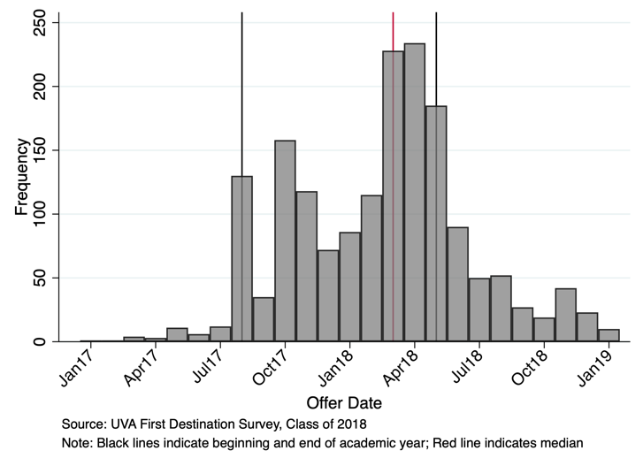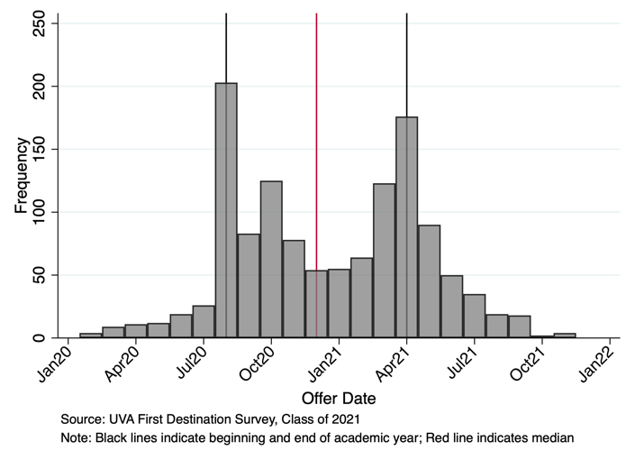

Figure 2: Difference in Offer Date and Graduation Date by Graduation Year
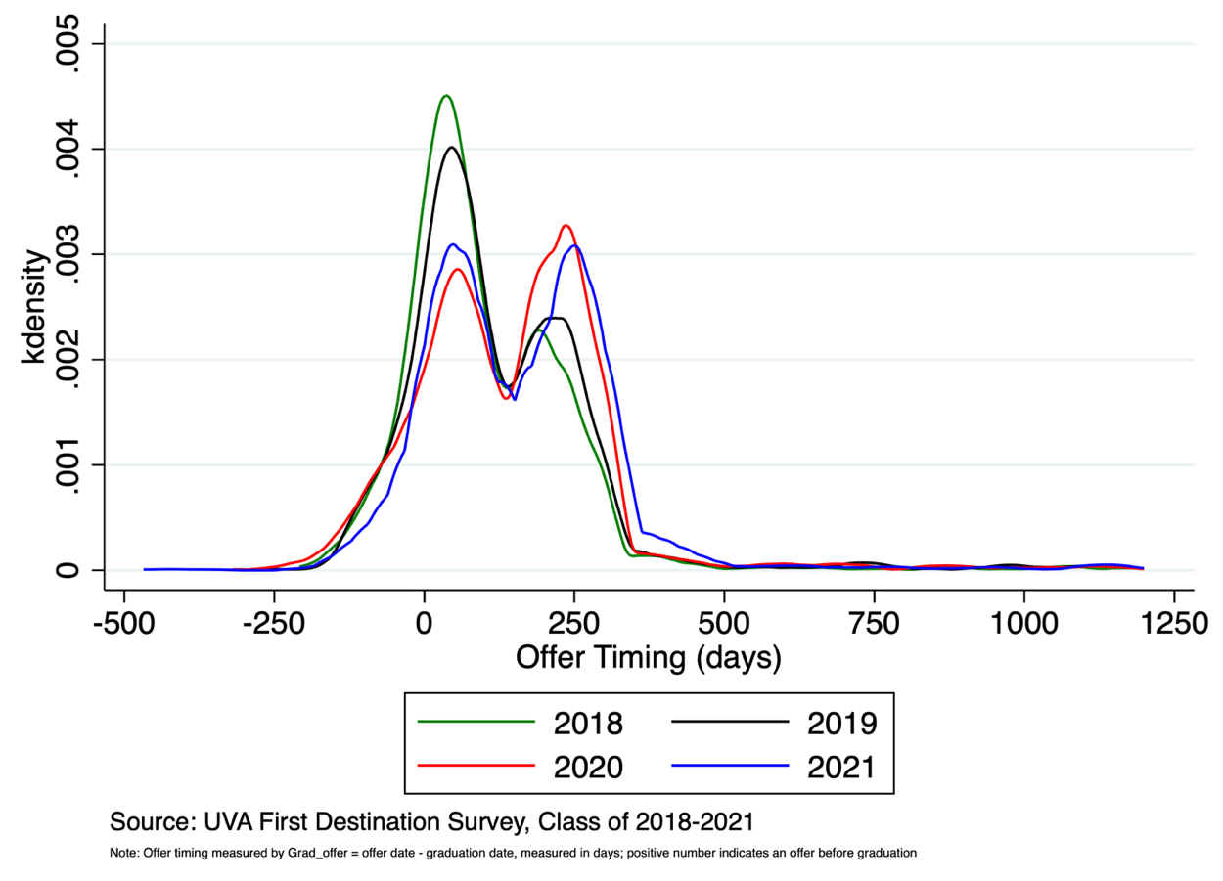

Figure 3: Difference in Offer Date and Graduation Date by Gender, Class of 2021
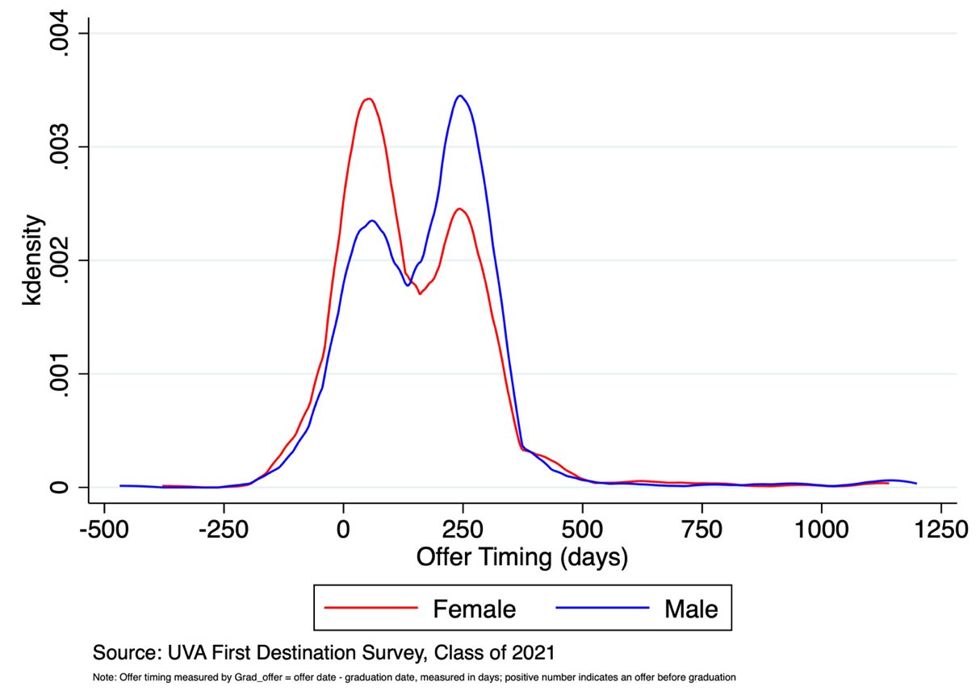

Figure 4: Gender Differences in Offer Timing, Class of 2018 & 2021
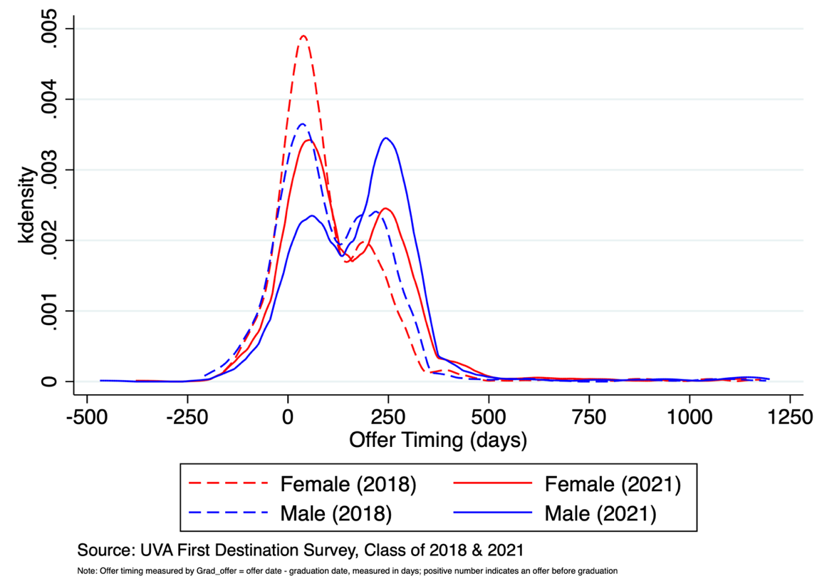

Figure 5: Difference in Offer Date and Graduation Date by Ethnicity, Class of 2021

